**Gilbert Karanga Kachanyi**

[**kachanyig@gmail.com**](mailto:kachanyig@gmail.com)

**+1 469 403 9847**

**Industry Grade Project 1**

**Building a CI/CD Pipeline for a Retail Company**

**Task 1: Clone the project from the GitHub link shared in resources to your local machine. Build the code using Maven commands.**

I downloaded the folder from the LMS portal and created a local repository using Git Bash. Afterward, I installed Java and Maven on my virtual machine to facilitate the build process for my code. After that, I compiled, tested, and packaged my code using Maven commands.

Java installation

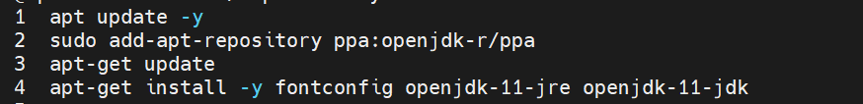

Maven installation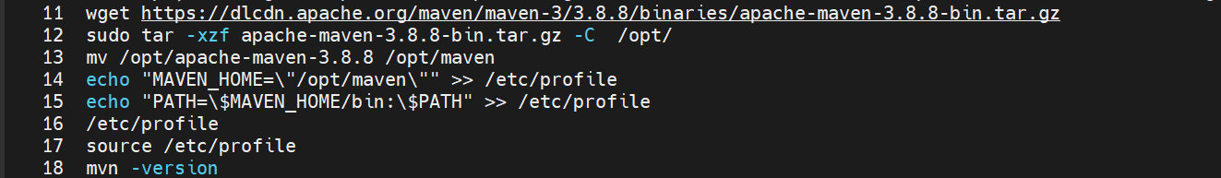

Code compile.

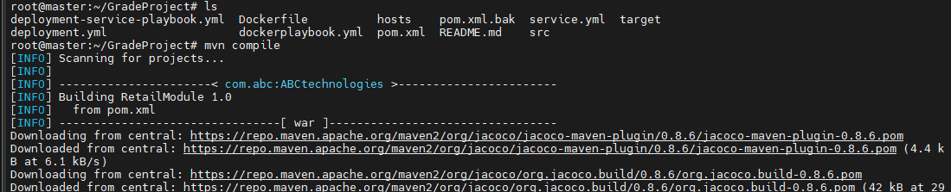

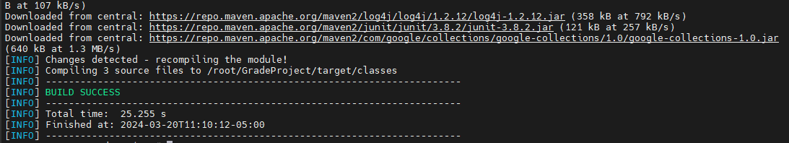

Code testing 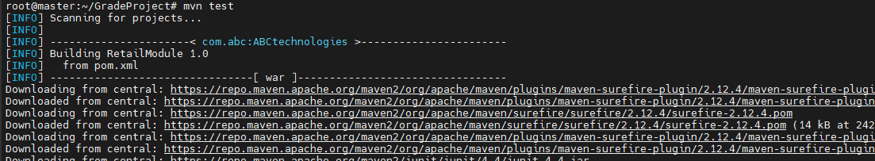 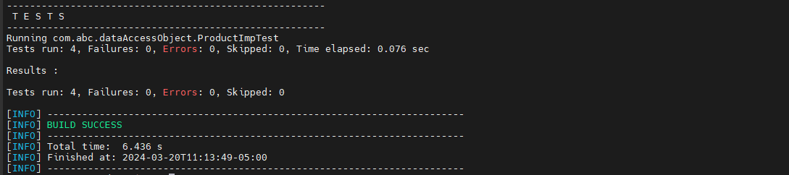

Code Packaging 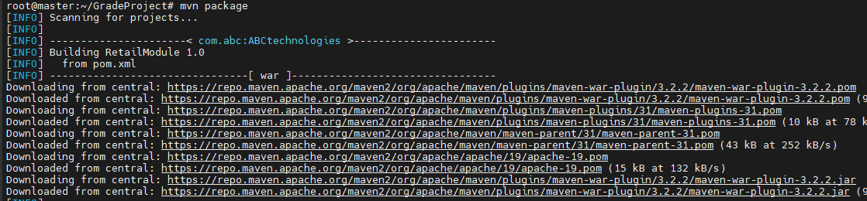 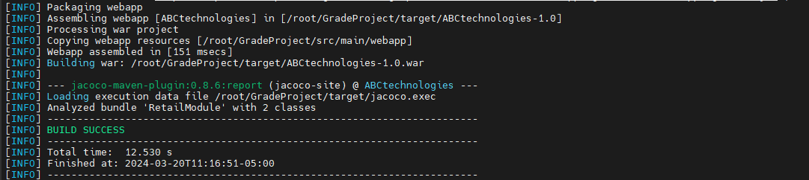

**Task 2: Set up the Git repository and push the source code. Then, log in to Jenkins.**

**1. Create a build pipeline containing a job for each**

**• One for compiling source code**

**• Second for testing source code**

**• Third for packing the code**

**2. Execute the CI/CD pipeline to execute the jobs created in step 1**

**3. Set up a master-slave node to distribute the tasks in the pipeline.**

I then created a remote repository on GitHub and used Git Bash to push my directory containing the files and Java code to GitHub. <https://github.com/GilbertEdureka/GradeProject.git>

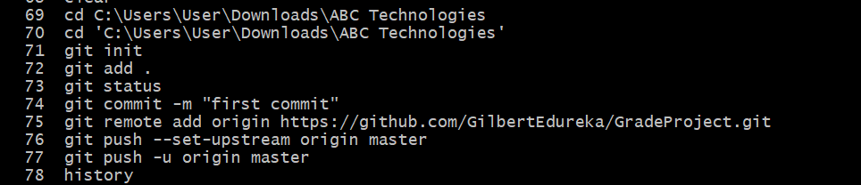

I installed Jenkins on my master server. Java needed to be installed as a prerequisite which I had already done in Task 1. Commands to install Jenkins 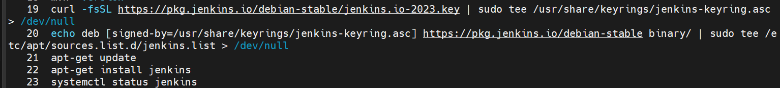 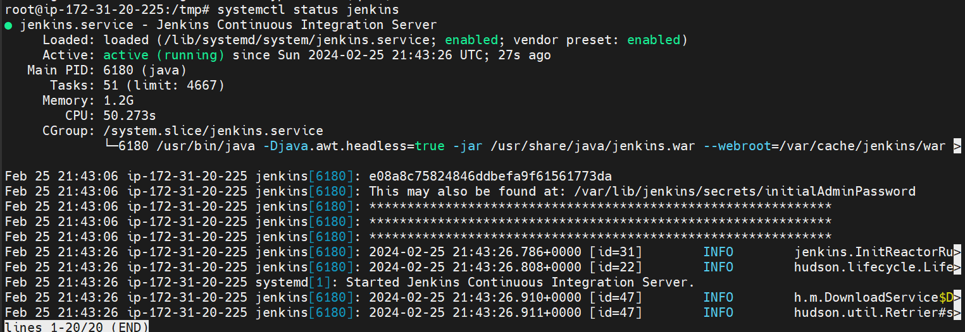

I accessed the Jenkins dashboard using my public IP and port number. Then, I navigated to the initialAdminPassword path and copied the password. Afterward, I proceeded to install the suggested plugins. 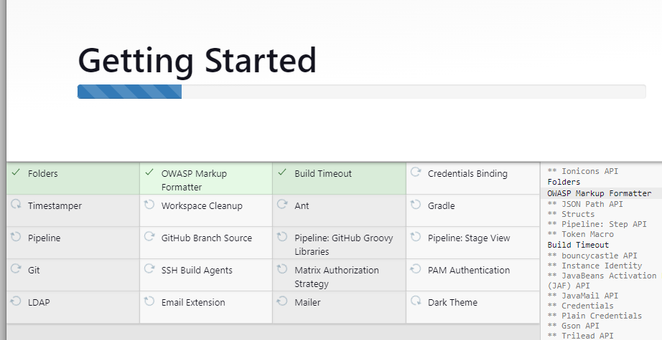

I then configured Java and Maven with Jenkins from the Tools section of Manage Jenkins. I obtained the home paths for Java and Maven by running the mvn -version command.

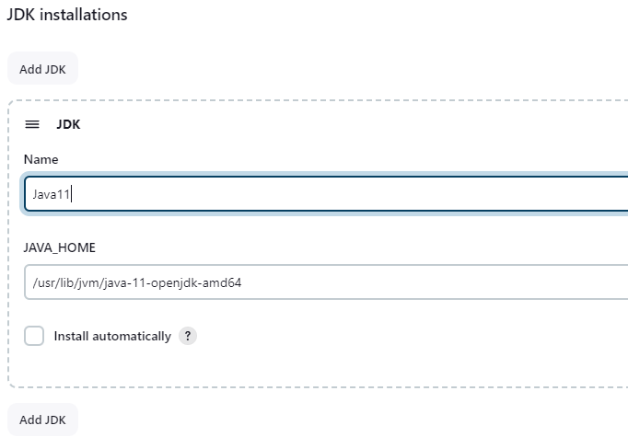

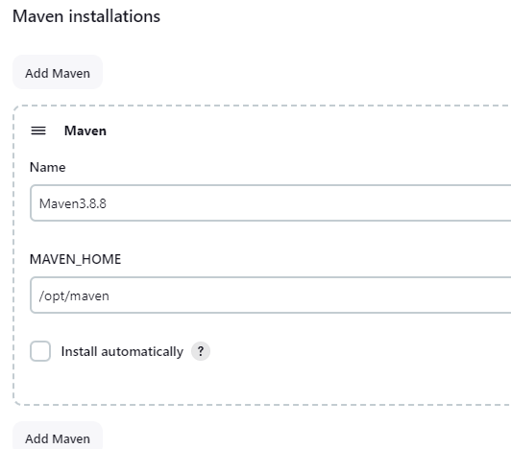

I then created a feestyle project called Compile. 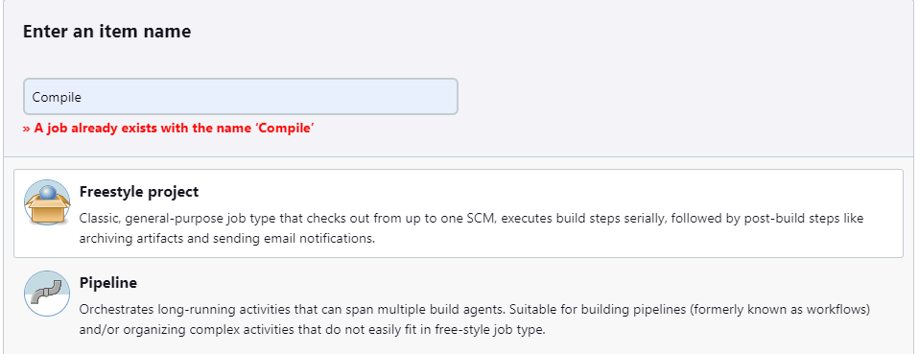

I moved on to configure my Compile job, adding in my git repository and maven goal, compile.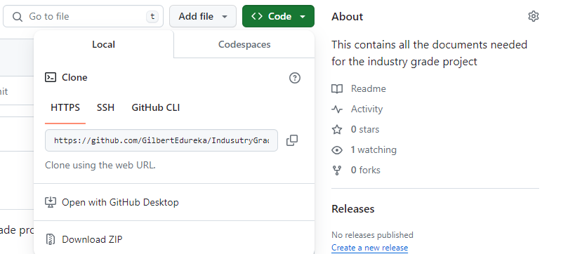 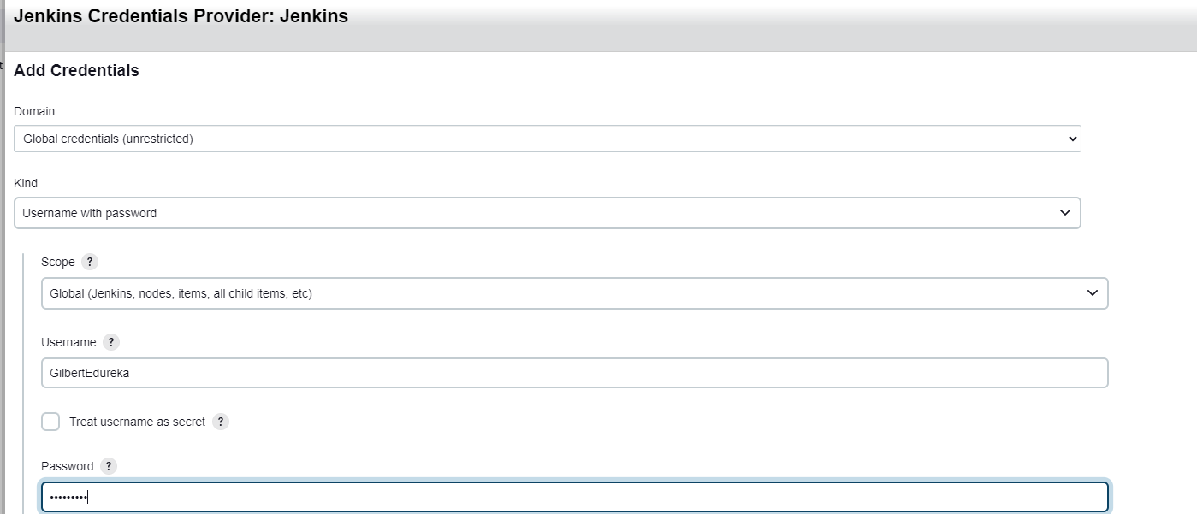 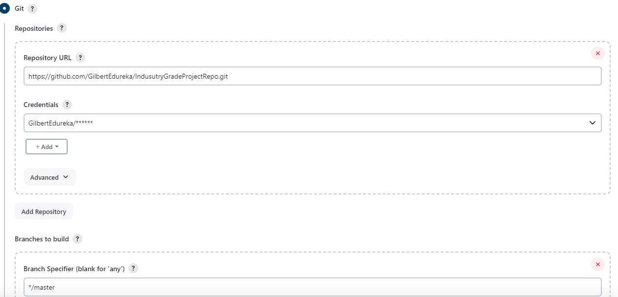

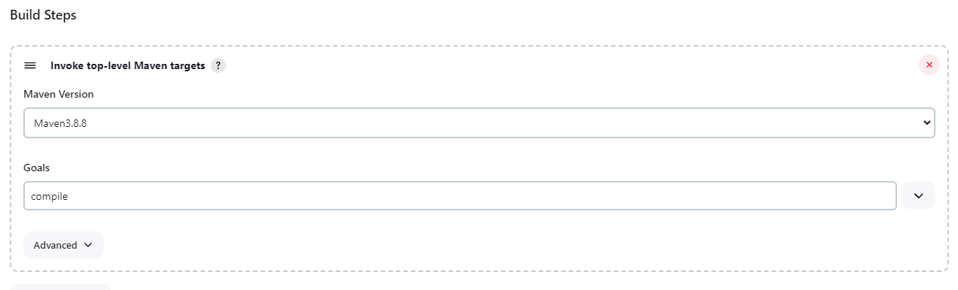

I then executed my Compile job which runs successfully 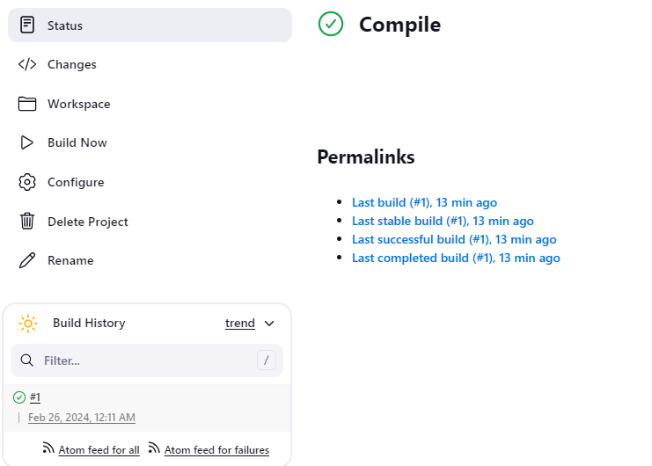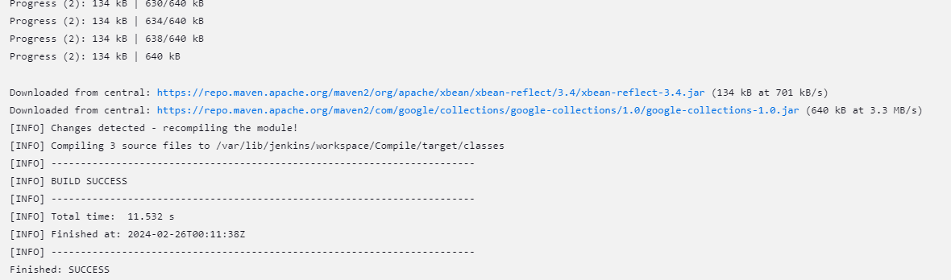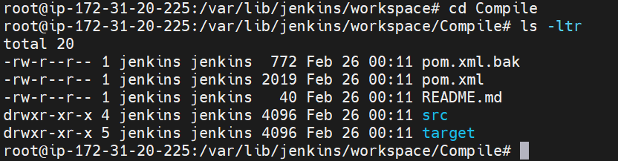

I then created and configured my Testing job, using ‘test’ for my maven goal.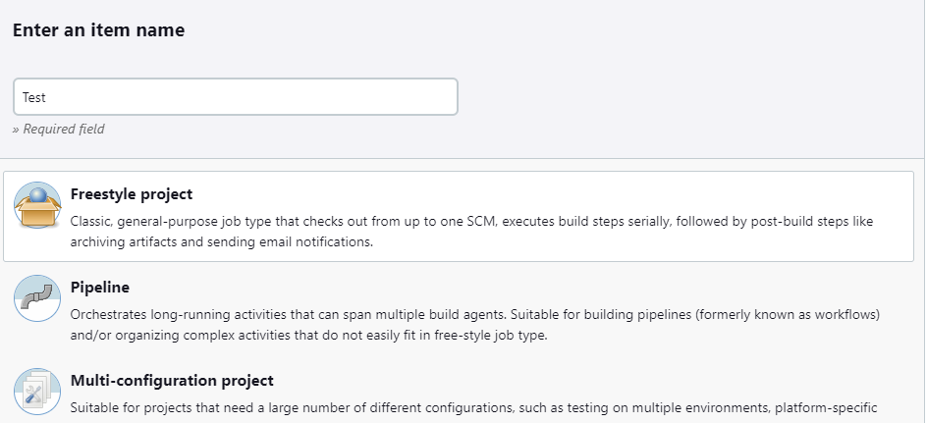 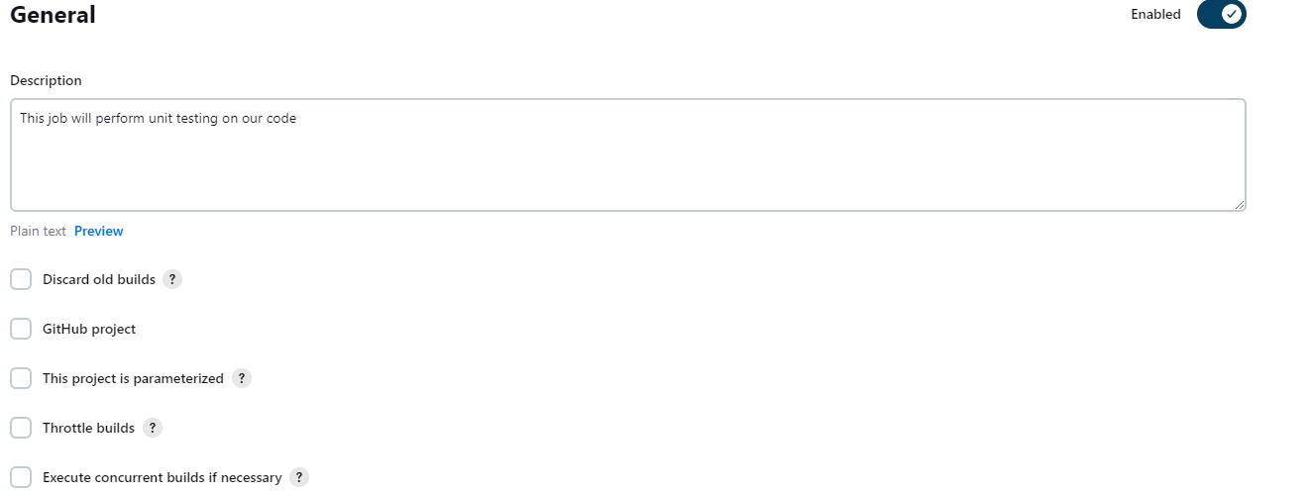

Testing job runs successfully

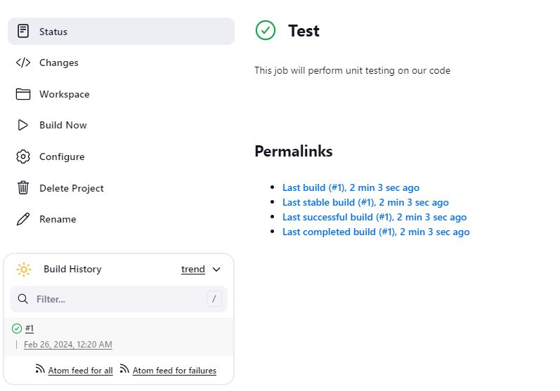

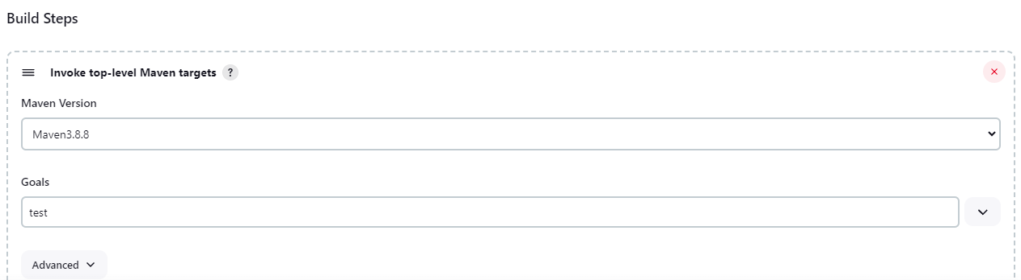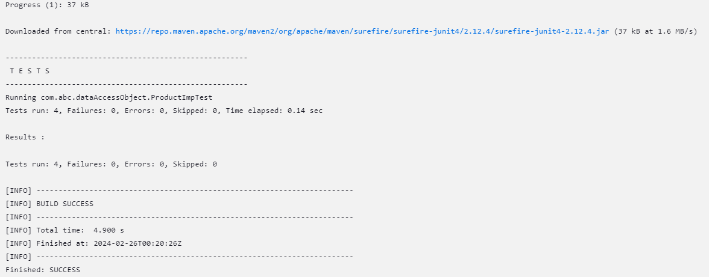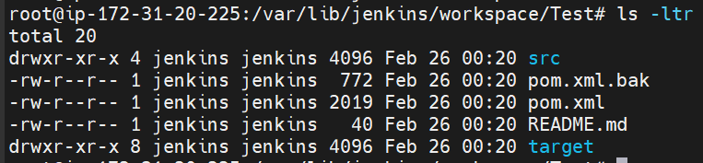

I then created and configured my Package job, using ‘package’ for my maven goal.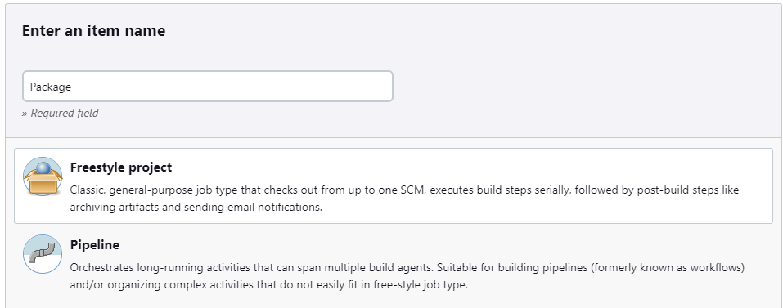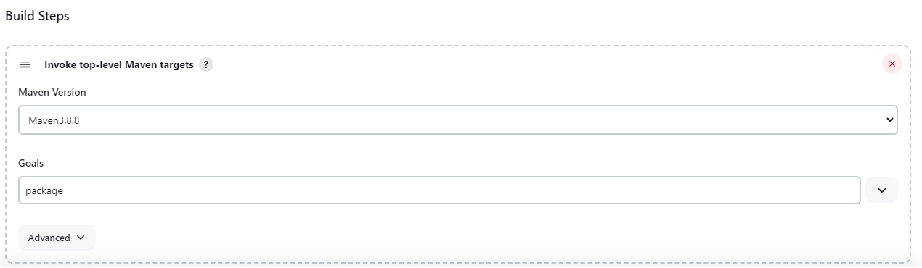

Package job runs successfully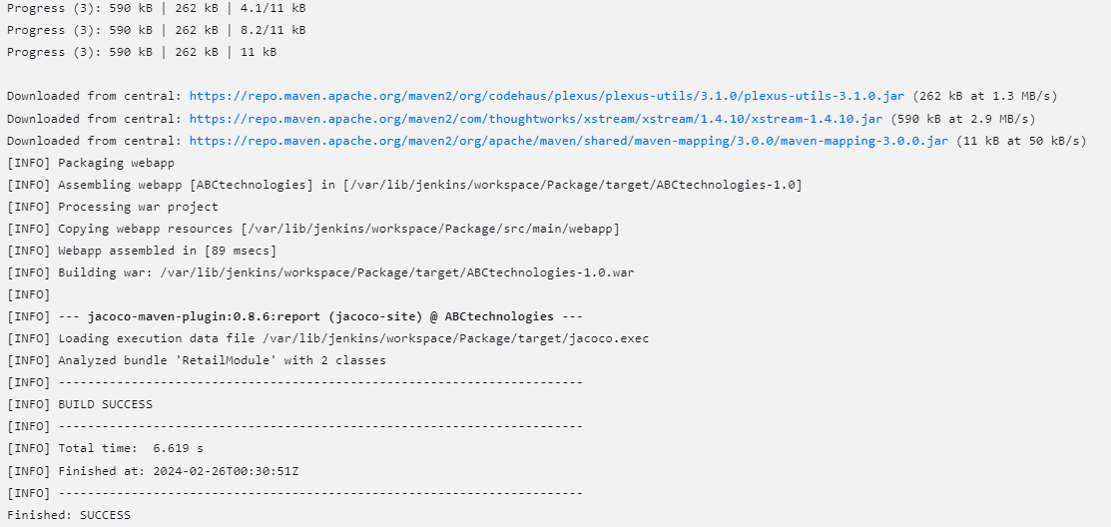

We are able to see our .war file in our target folder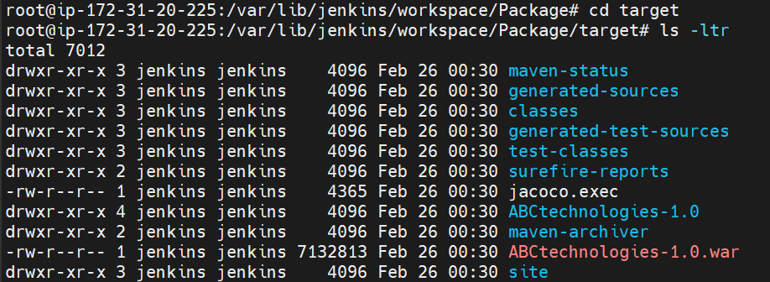

**2.** I created a pipeline project called pipeline Job which enable ran the entire process from code compile to packaging using the CICD pipeline. 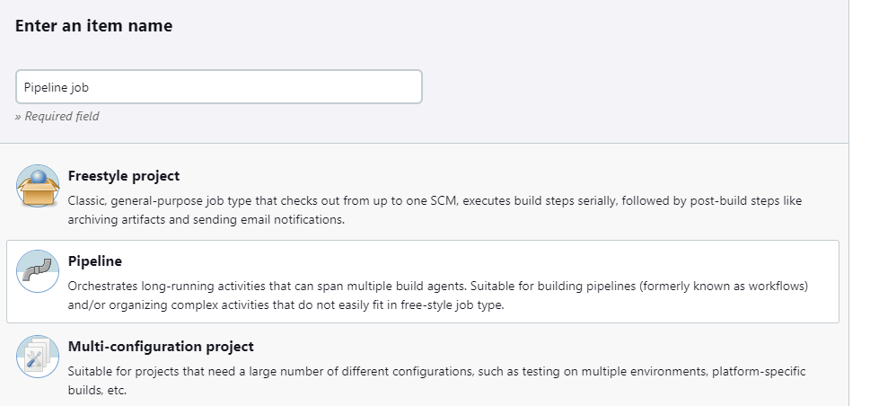

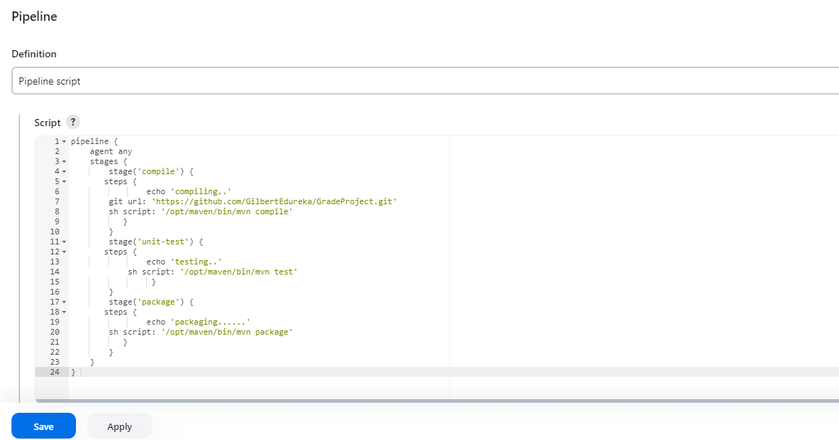

My Pipeline job runs successfully creating my war file on my master server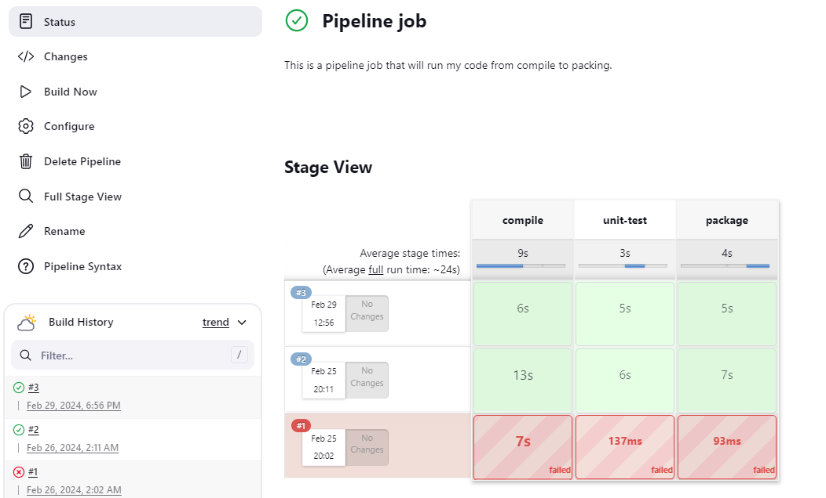 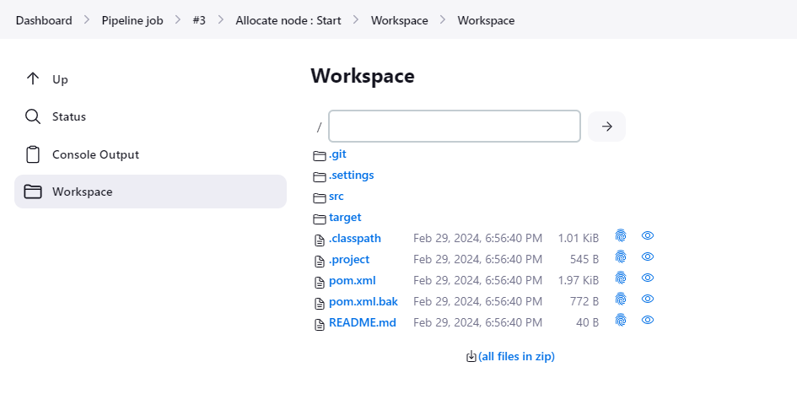

Compiling successfully 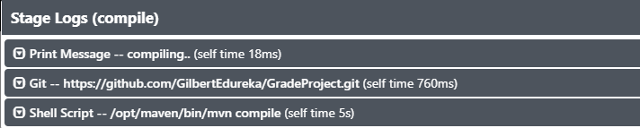

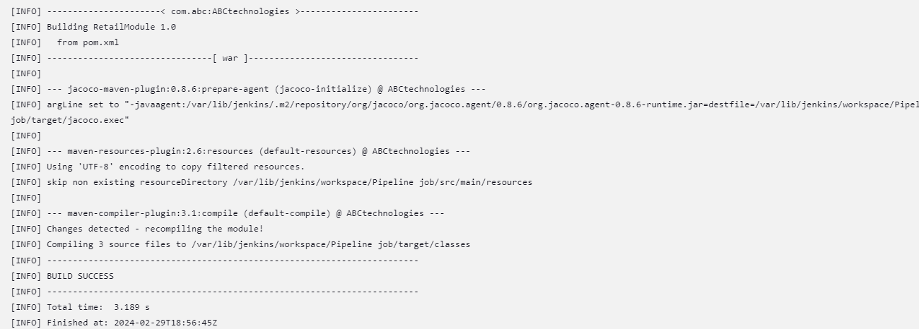

Testing successfully 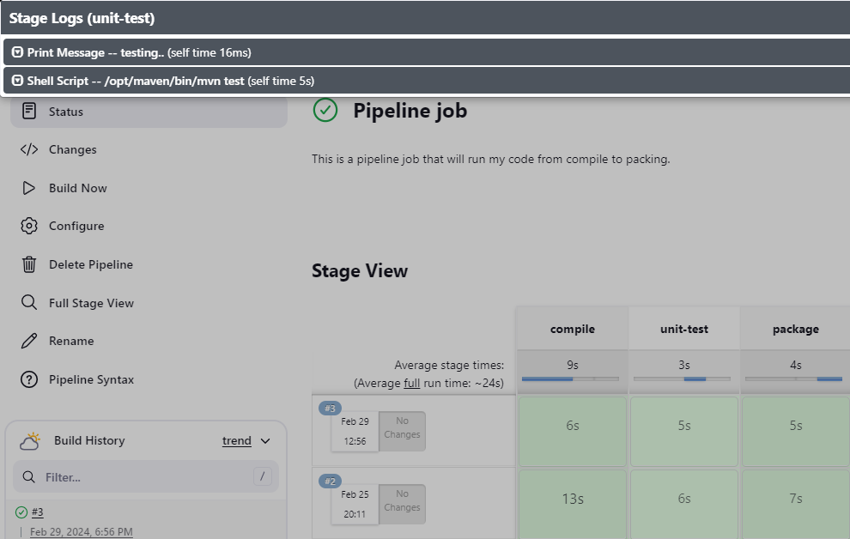

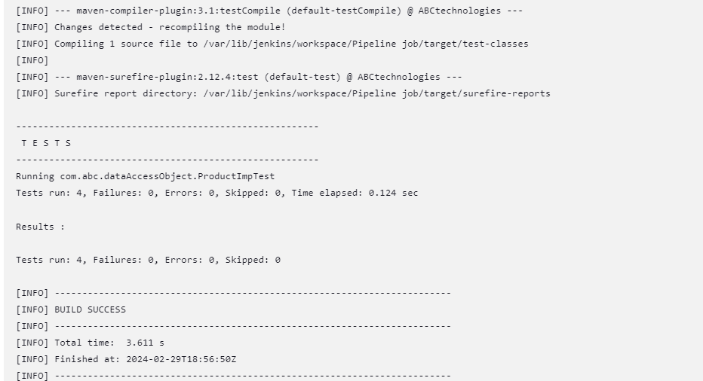

Packaging success 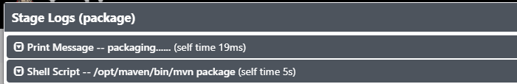

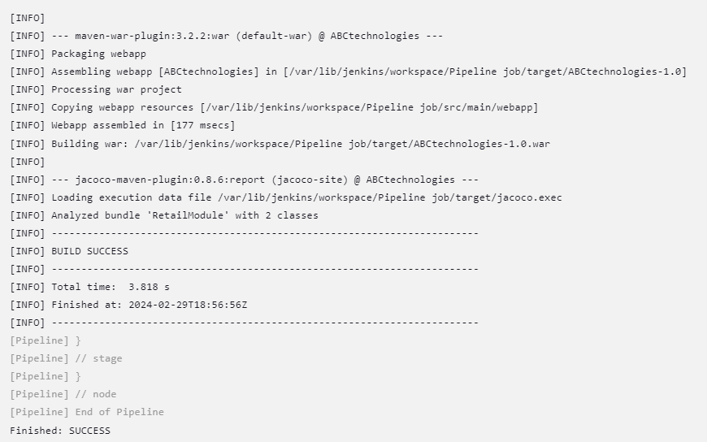

The pipeline job runs on the masterserver creating the workspace containing my compile, test and package job. I war file is created in our target folder 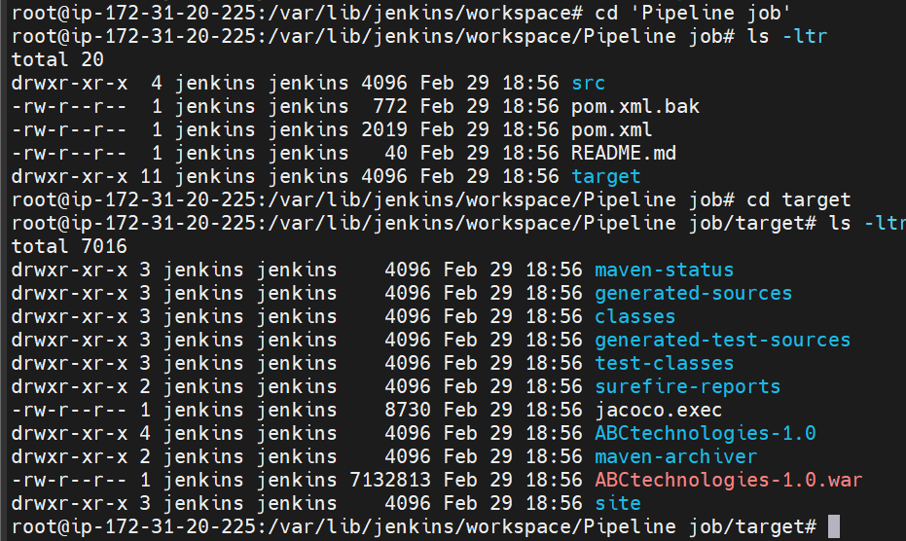

I created a new node called Workernode1 and configure it as below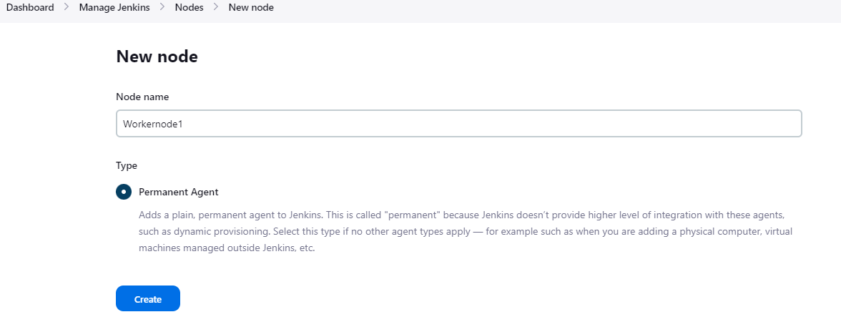 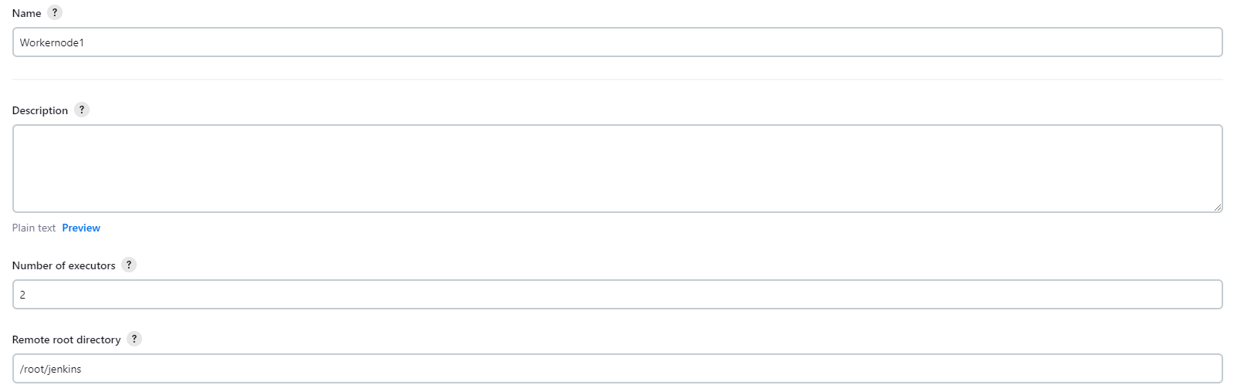 For the remote root directory, I created a directory called jenkins and used the path. 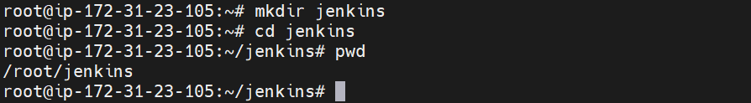 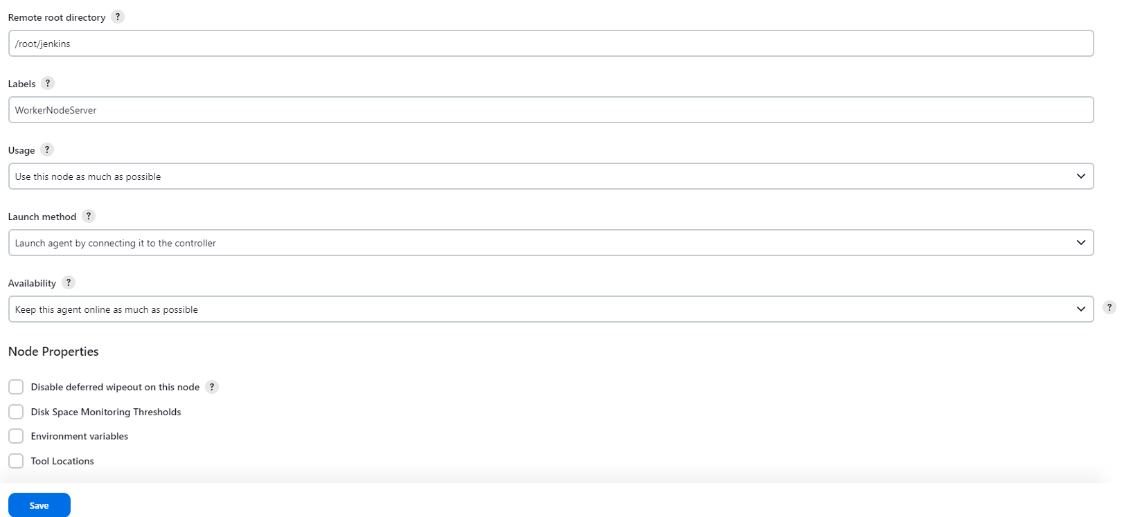

I changed the agents to random on jenkins so that the system can select any port to run hence preventing interrupting other programs.

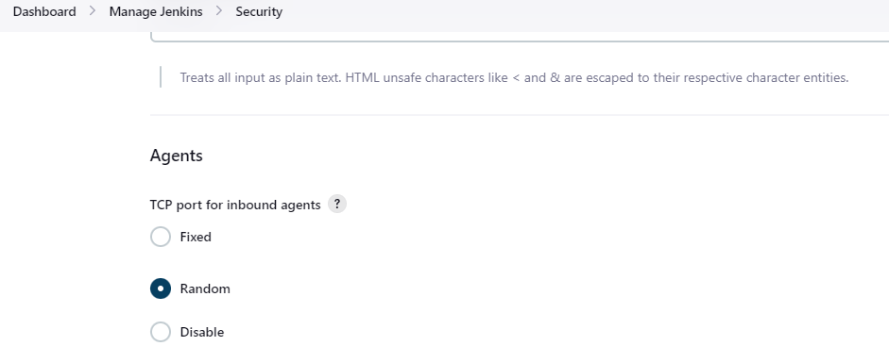

I am going to install java and maven on my workernode in a jenkins directory I am going to create.  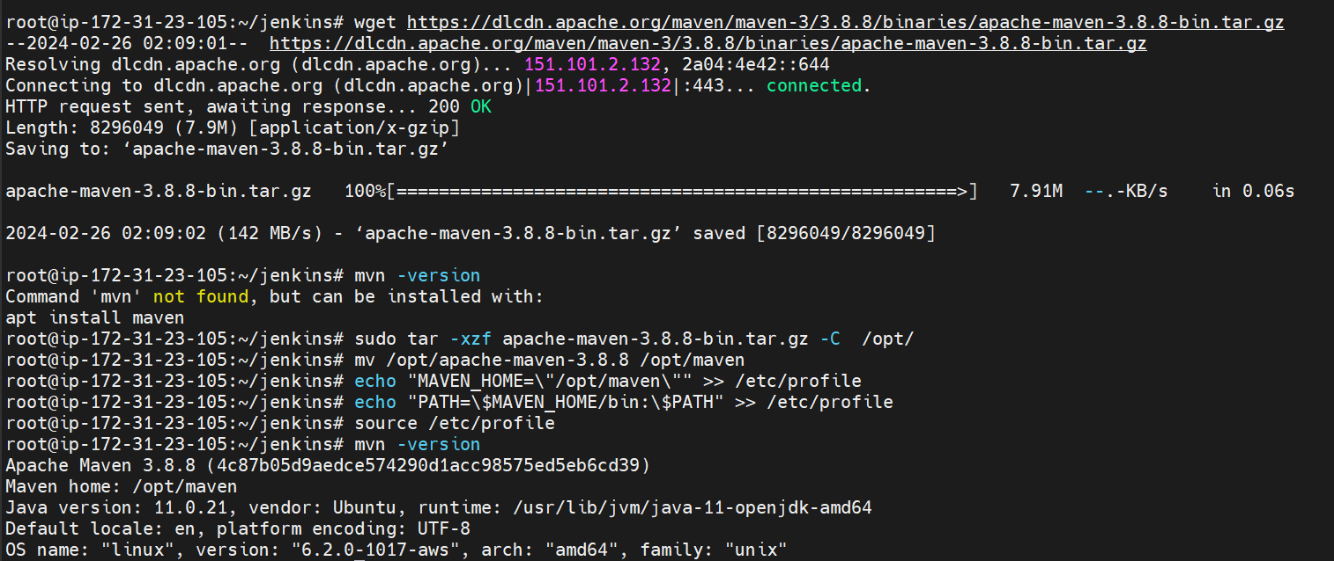

Our new node is not connected 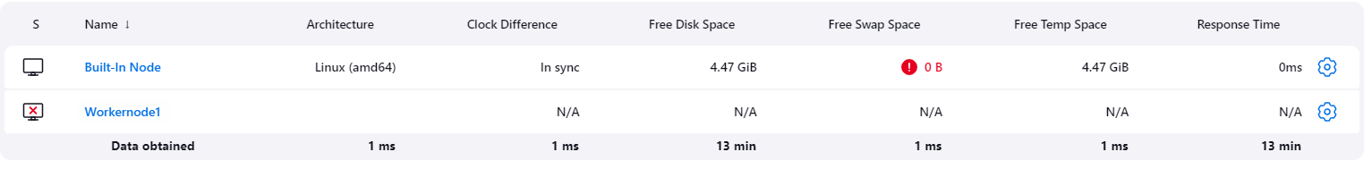I will connect it using these commands 

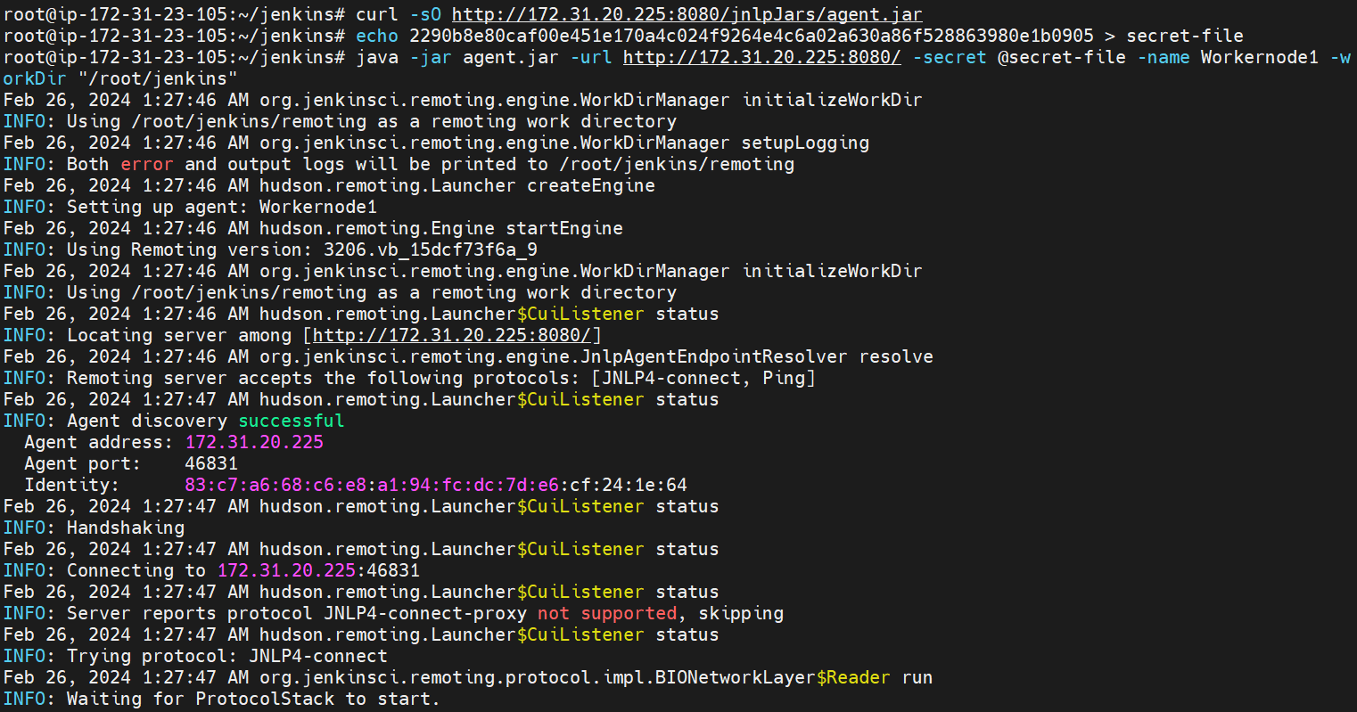now my workernodeserver is connected 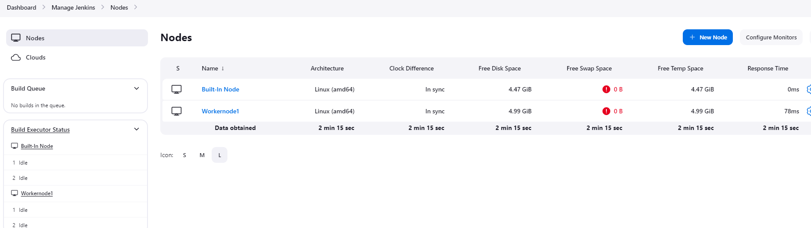

Now I updated the freestyle package job to create our war file on our Workernodeserver while the compilation and testing jobs are ran on our Master server. 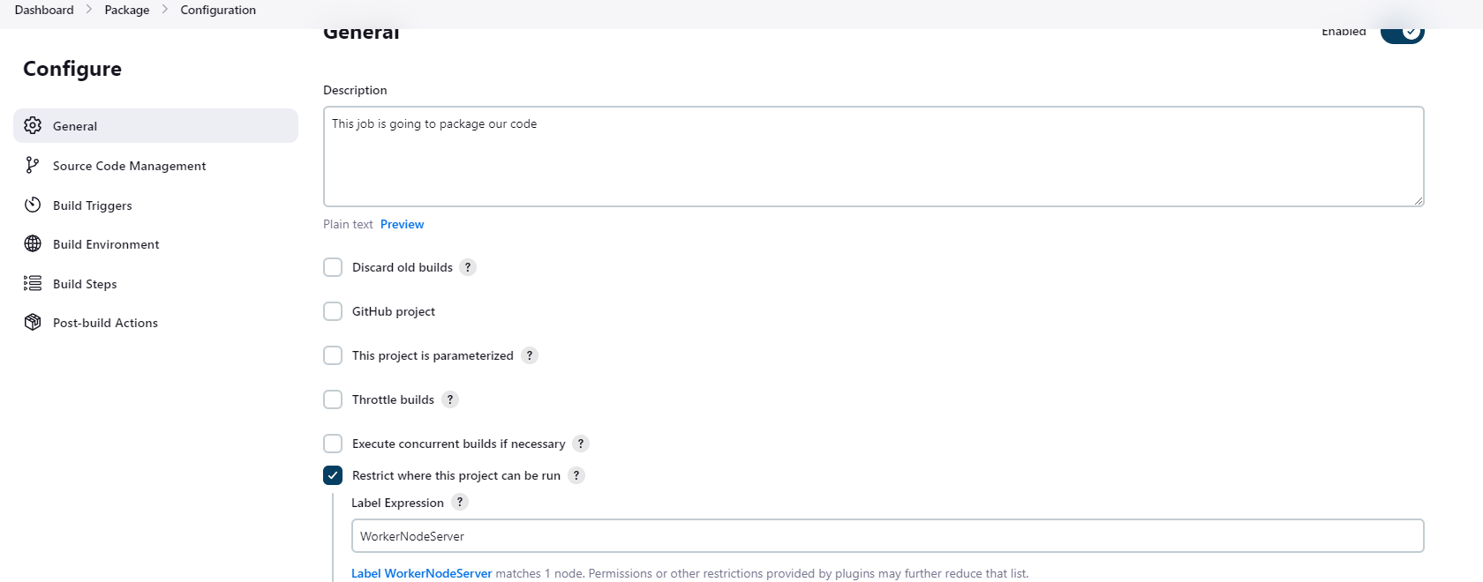

Now I configured webhook and pollscm on my project so my pipeline will run anytime there is a commit on my git code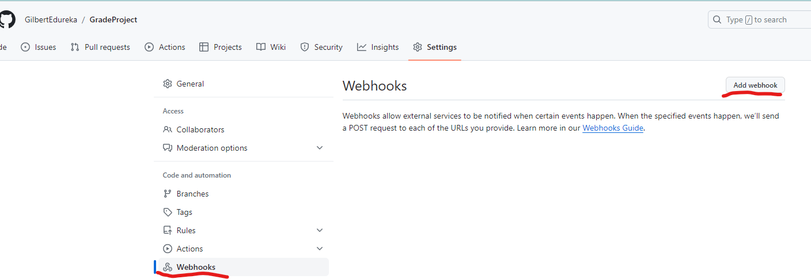 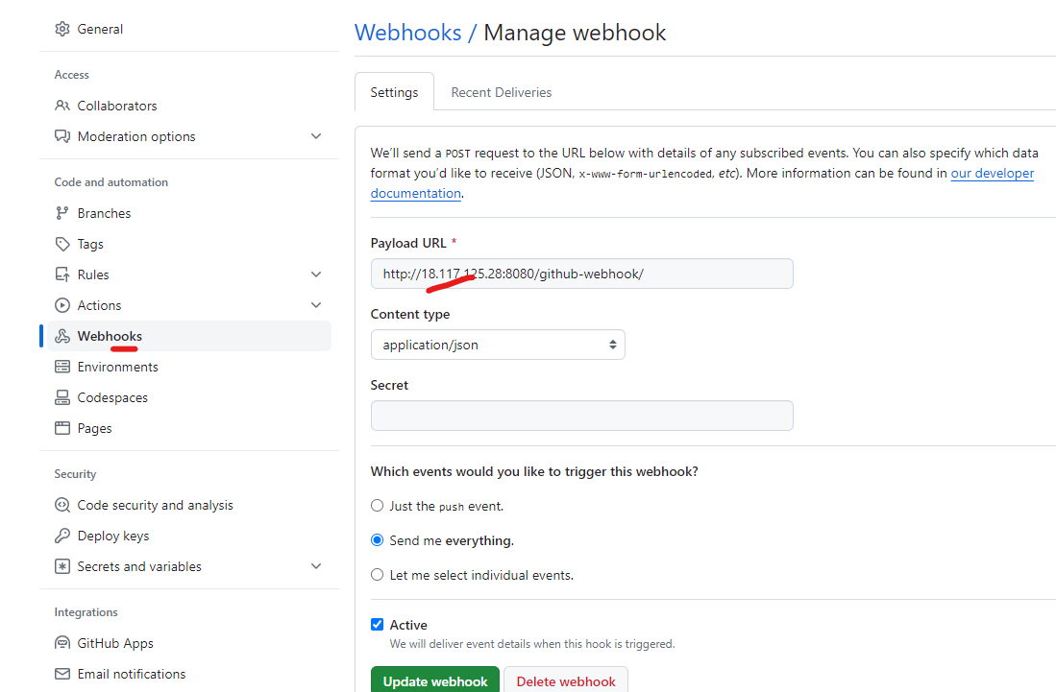 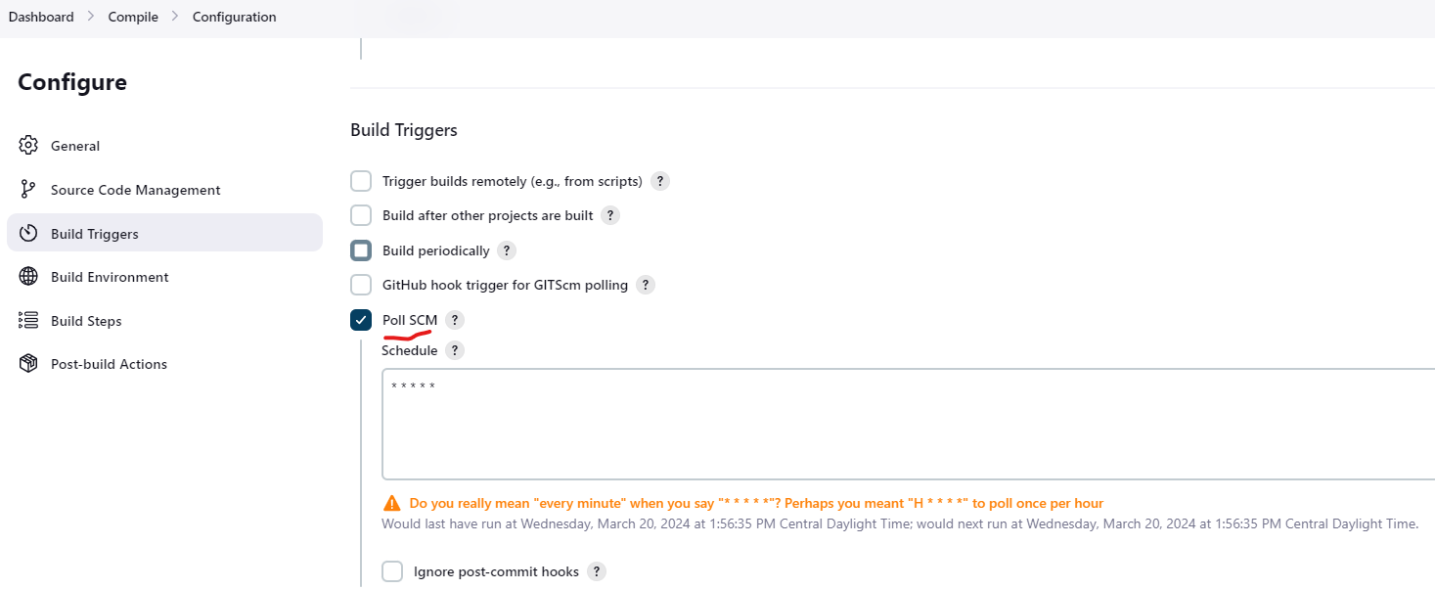 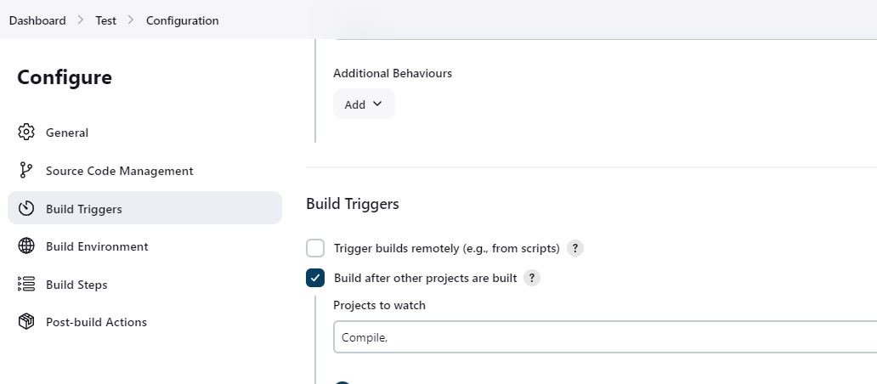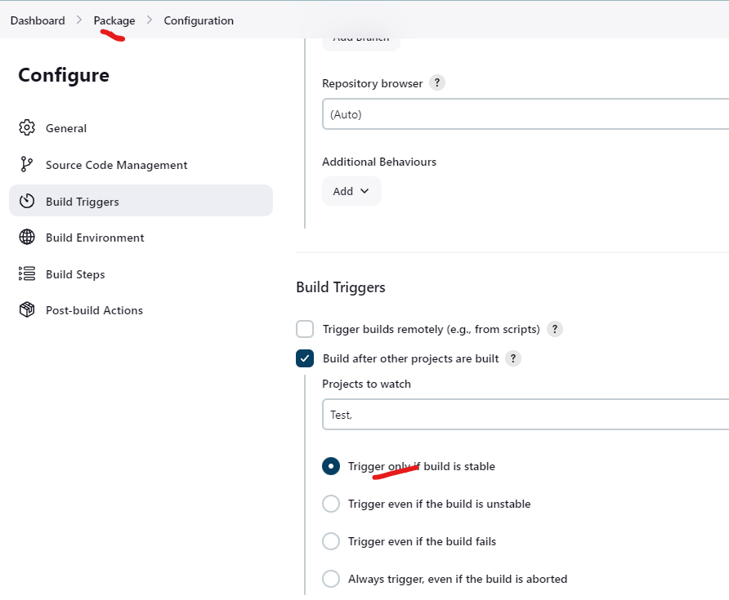

Master folder before running job, no workspace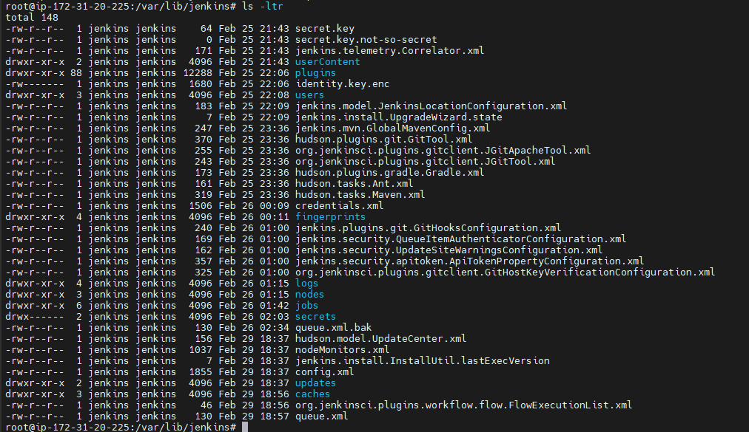

Workernode Jenkins folder before running our job, no workspace folder

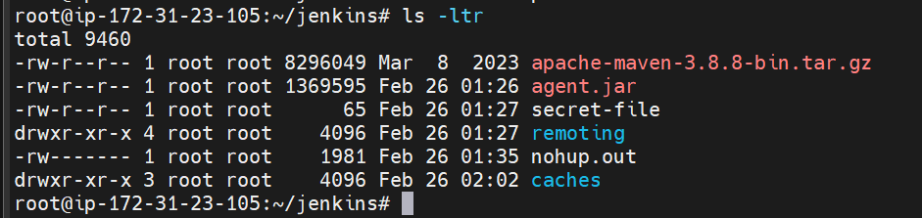

Added the line “ this is for testing webhook” to trigger my compile job

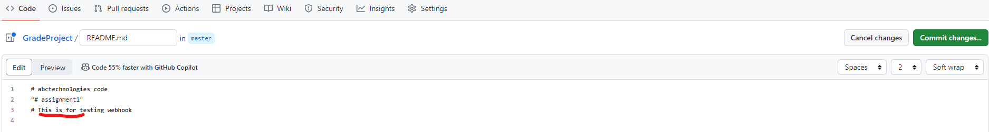

Commiting the change triggered our compile job which also triggered the test and package jobs 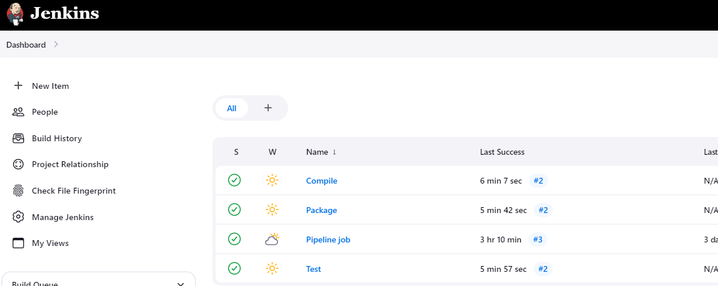

The workspace is created on my master server containing the compile and testing jobs but no package job

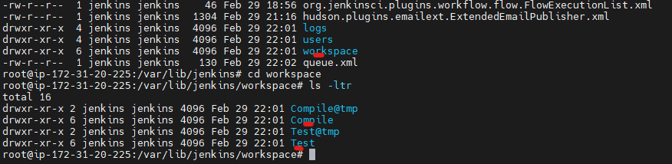 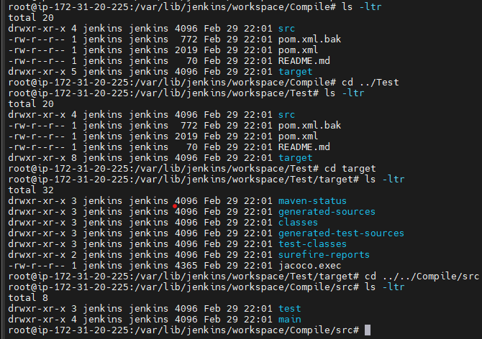

Workernode after running job showing the package job ran on the workernode creating the war file 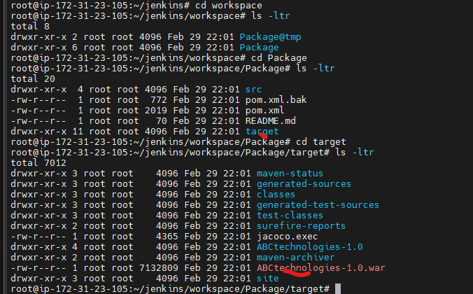

**Task 3: Write a Docker file. Create an Image and container on the Docker host. Integrate docker host with Jenkins. Create CI/CD job on Jenkins to build and deploy on a container.**

**1. Enhance the package job created in step 1 of task 2 to create a docker image.**

**2. In the Docker image, add code to move the war file to the Tomcat server and build the image.**

First, I installed Docker on my servers and then installed the necessary plugins required for deploying a container using Jenkins. Following that, I created a Dockerfile, which would generate a customized image of my operating system with my Tomcat application installed within it, along with my WAR file copied into the image. This ensures that whenever I create a container, it will contain my application, allowing me to access it on the Tomcat server from within the container.

I installed docker on my master and worker server. 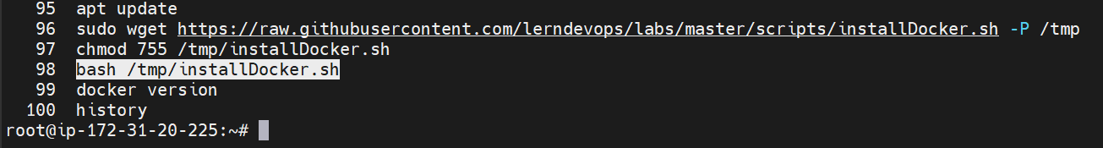 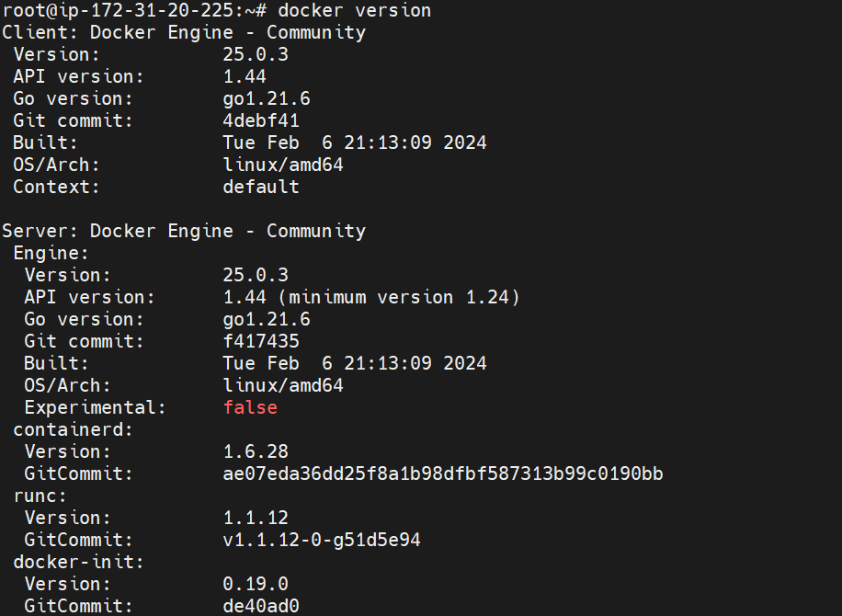 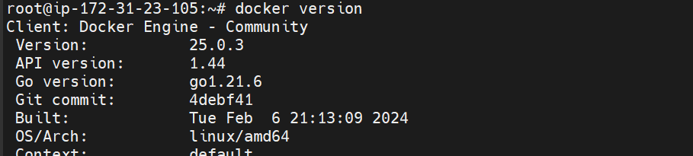

In Jenkins I installed the following plugins: Cloudbees Docker Build and Publish plugin and docker plugin. 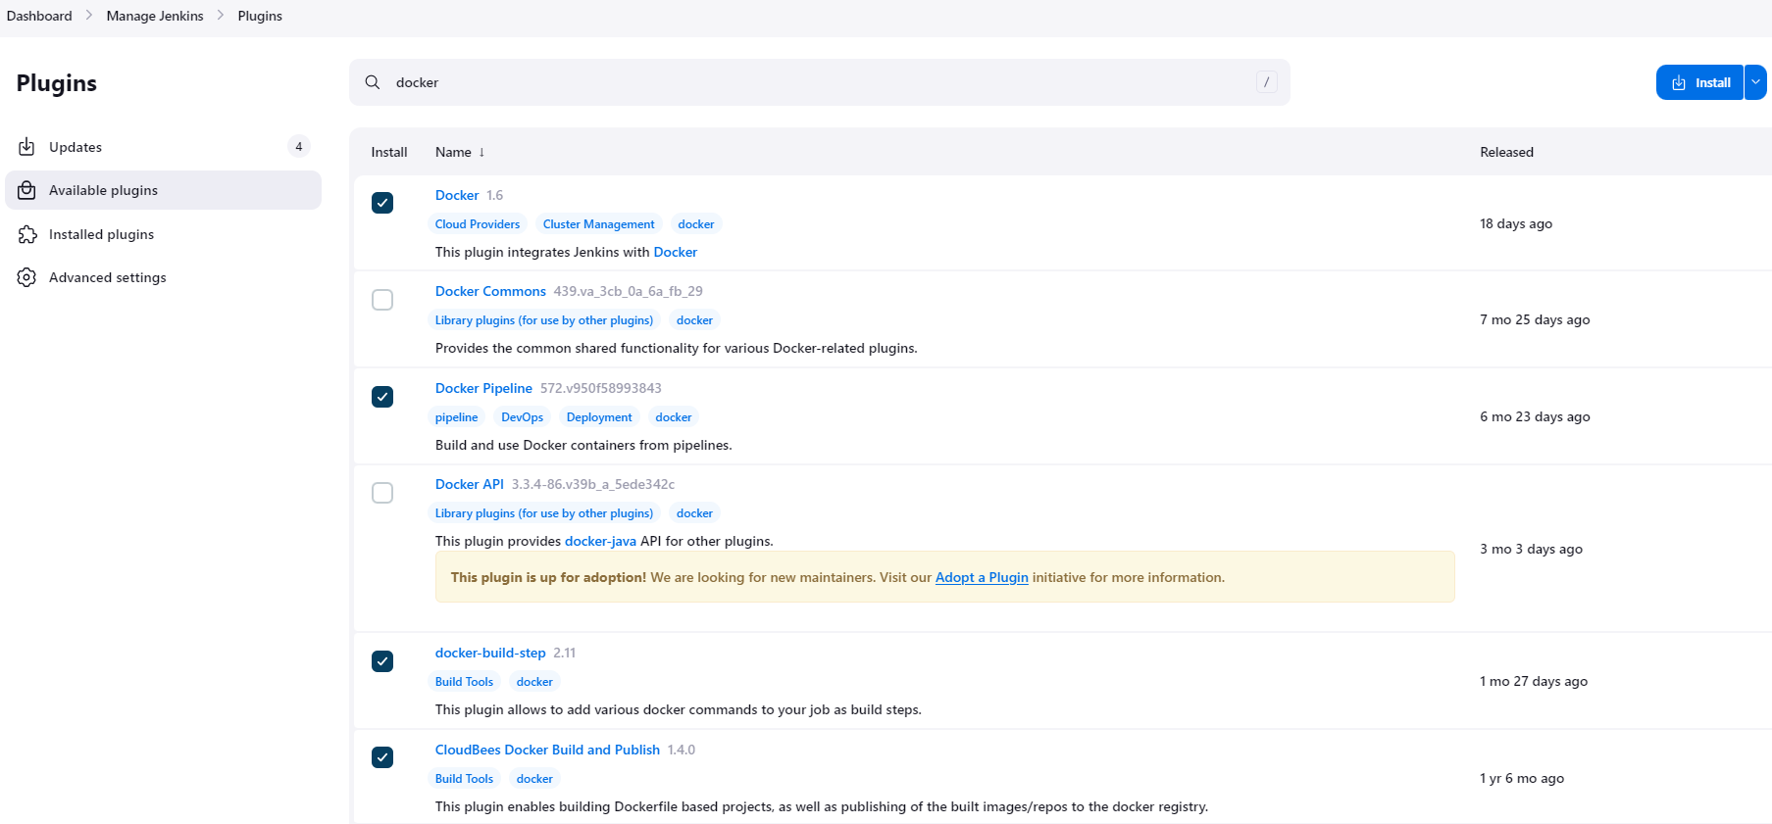 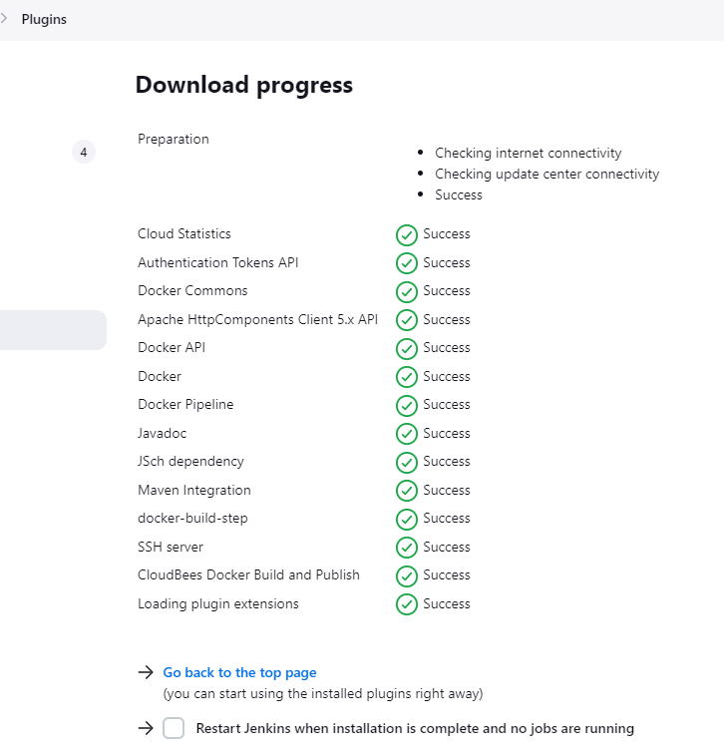

In Jenkins I updated my package, adding a build step, shell command to log into my docker hub and another step, the docker build and publish option to build my image from my dockerfile. I also provided the repository name 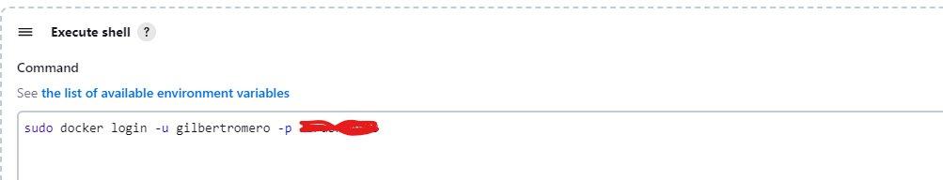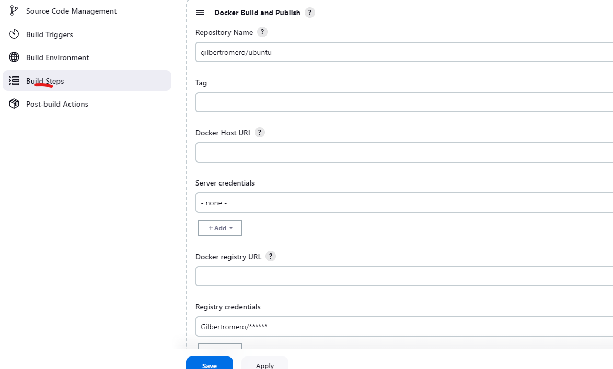 I created and provided the registry credentials for my docker hub account.

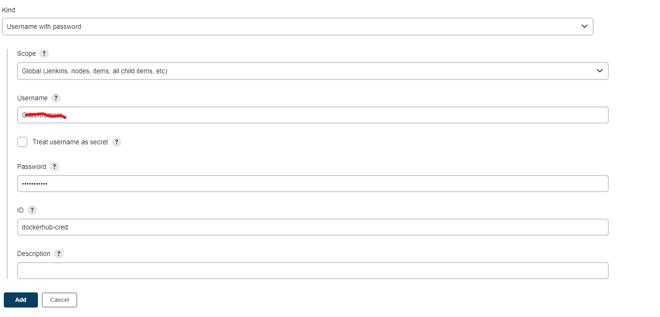

I created a Dockerfile and uploaded to my github project. This upload triggers Jenkins to run the compile job, testing, and my package job which creates my docker image from the Dockerfile. I can see the image on my docker hub and local server.

My Dockerfile

vi abcprojectdockerfile

FROM ubuntu:18.04

RUN apt-get -y update

RUN apt-get -y install openjdk-8-jdk wget

RUN wget https://archive.apache.org/dist/tomcat/tomcat-8/v8.5.55/bin/apache-tomcat-8.5.55.tar.gz -O /tmp/tomcat.tar.gz

RUN cd /tmp && tar xvfz tomcat.tar.gz

RUN mv /tmp/apache-tomcat-8.5.55 /opt/tomcat

COPY **/*.war /opt/tomcat/webapps/

EXPOSE 8080

CMD /opt/tomcat/bin/catalina.sh run

My job failed due to an error caused by naming the Dockerfile incorrectly. After renaming it to "Dockerfile," the job ran successfully, but encountered a different error.

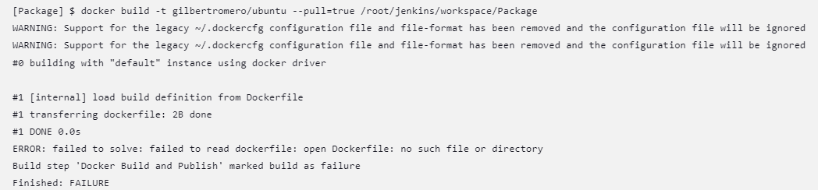

As seen below, I got another error showing that I do not have access to docker hub.

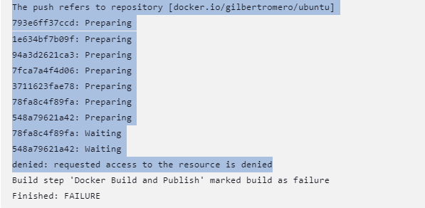

Logging into my Docker account locally using the command "docker login" resolved the error, allowing my package job to run successfully and push my images to Docker Hub.

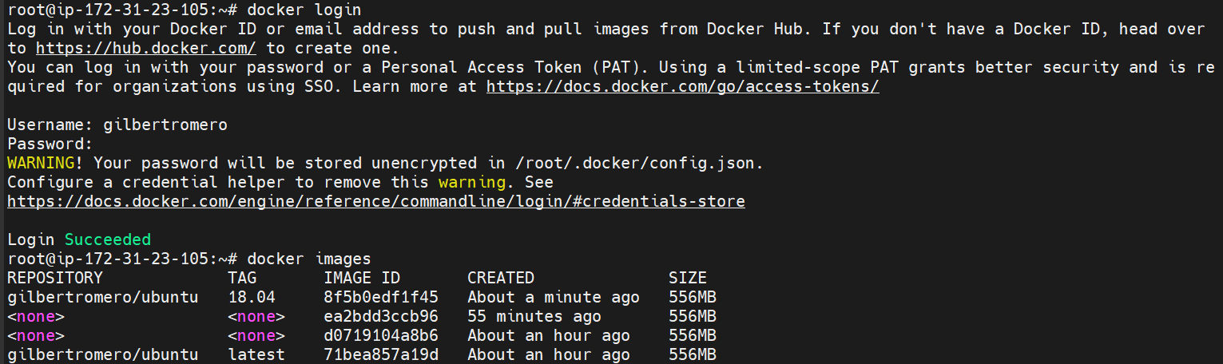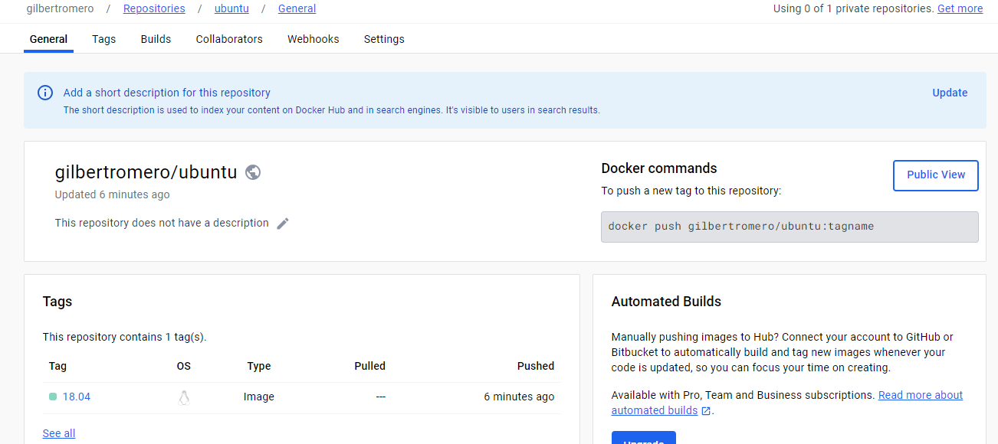

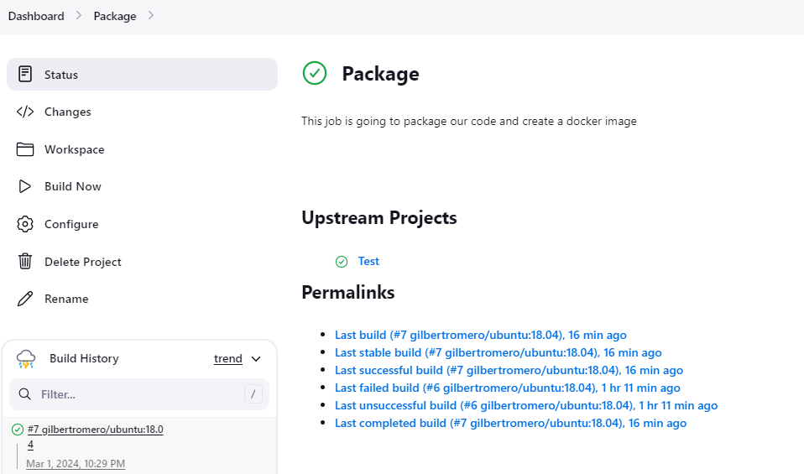

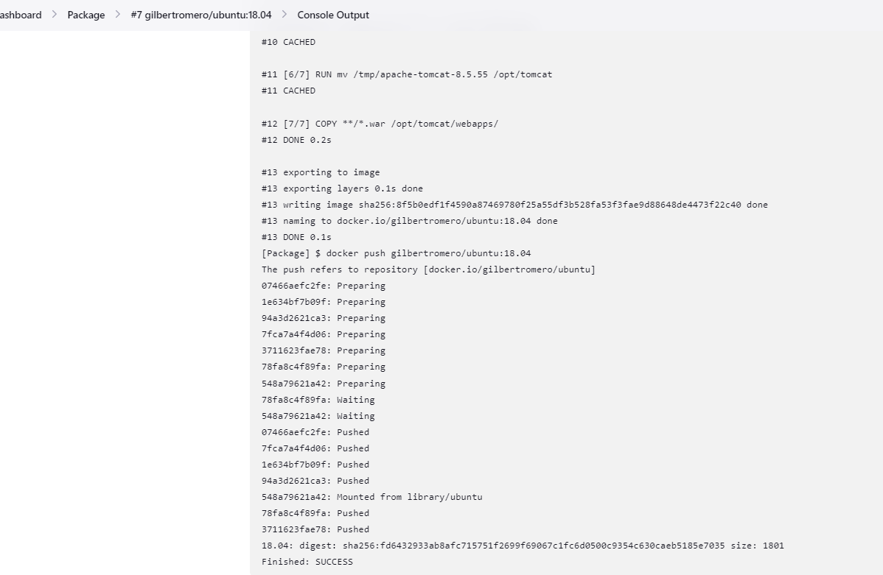 After creating a container from the image, I logged into the container and found my Tomcat application in the tmp folder.

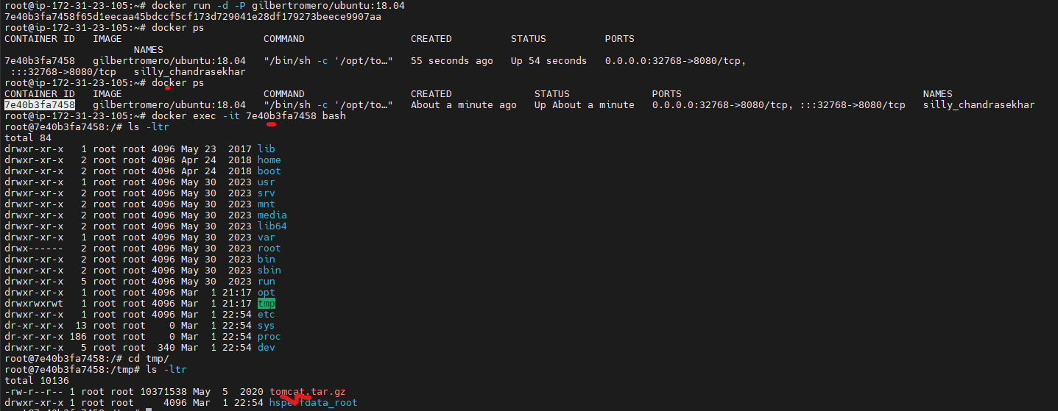

I can see my war file in the container in my webapps folder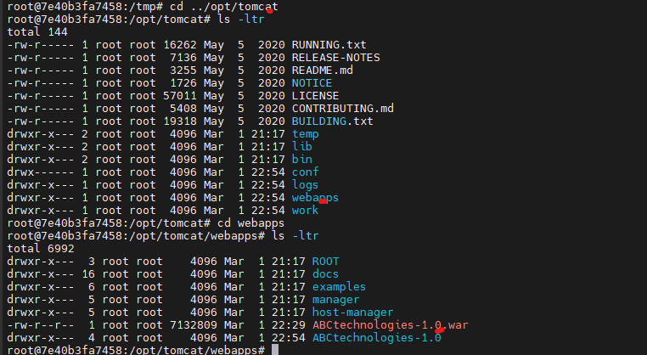 Using the public IP address of my VM and the port mapped to the container's port, I can access the Tomcat server through my browser

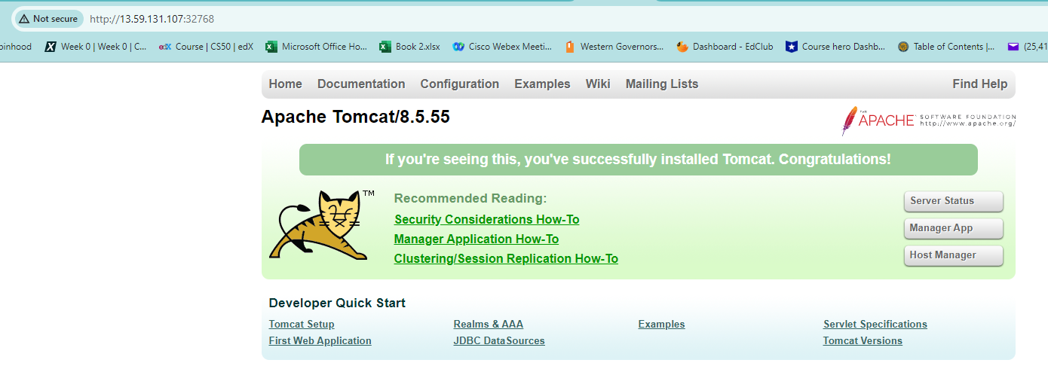

I am able to access the app

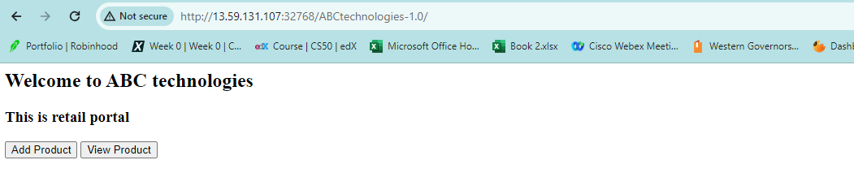

**Task 4: Integrate the Docker host with Ansible. Write an Ansible playbook to create an image and create a container. Integrate Ansible with Jenkins. Deploy Ansible-playbook. CI/CD job to build code on ansible**

**and deploy it on docker container**

**1. Deploy Artifacts on Kubernetes**

**2. Write pod, service, and deployment manifest file**

**3. Integrate Kubernetes with Ansible**

**4. Ansible playbook to create deployment and service**

First, I installed Ansible on my master server and Kubernetes on both my controller and worker nodes. Docker was also installed on both servers as per Task 3 requirements. Following that, I created a sample pod named Pod2 from an Nginx image, which was deployed by my controller to the worker node.

To integrate Jenkins with Ansible, I installed an Ansible plugin to enable running my playbook from Jenkins. I then configured the Ansible path for execution. Subsequently, I created a new freestyle job named "package_docker" in Jenkins. The build step was configured to package the job, log into my Docker Hub account, and create an image using the Dockerfile from GitHub, utilizing my Ansible playbook named "dockerplaybook.yml."

Next, I created Kubernetes manifest files and a playbook to run these manifest files for deploying my deployment, pods, and service. Afterward, I edited my Jenkins job "package_docker" to "jenkins_docker_kubernetes," adding another step to run the manifest file named "deployment-service-playbook.yml." This step created my deployment, pods, and service using the custom image created in the previous step.

First I installed ansible on my master server. 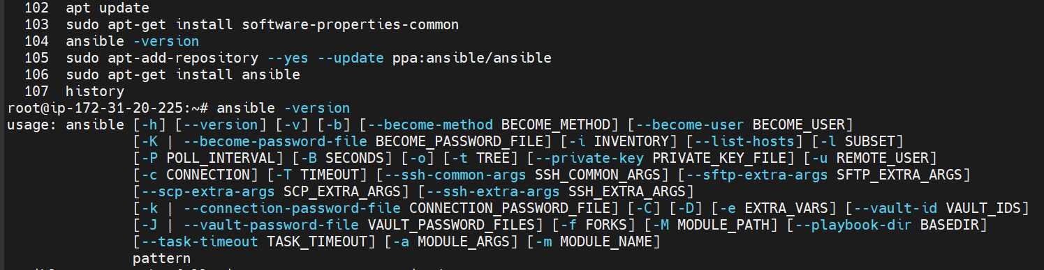

I also installed kubernetes on my controller and worker node. I had installed docker on both my master and worker server from task 3.

When trying to connect my Kubernetes master node to my work node, I encounder an error which I fixed by resetting my kubeadm using the kubeadm reset command 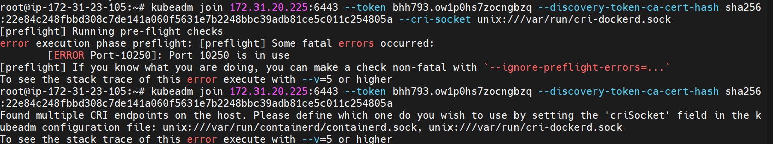

After resolving this issue, I was able to connect to my kubernetes worker node as seen below. I also created a sample pod, Pod2, from and nginx image which was created by my controller on my worker node

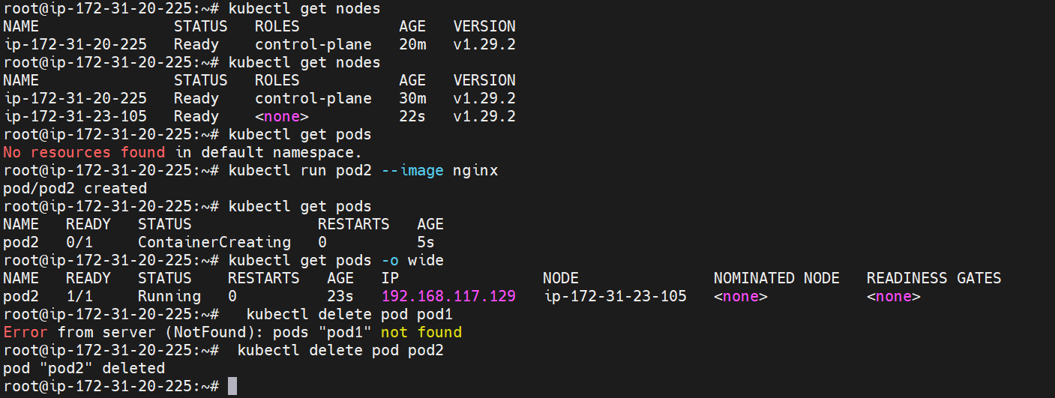

I first created my playbook and ran it locally to check if my playbook is working right.

- name: Build Docker image

hosts: web

become: yes

vars:

ansible_user: root

ansible_python_interpreter: /usr/bin/python3

tasks:

- name: Build Docker image from Dockerfile

shell: |

docker build -t newtomcat /root/GradeProject/

tags:

- build_image

- name: Run Docker Container

docker_container:

name: tomcatcontainer

image: newtomcat

state: started

ports:

- "8090:8080"

tags:

- run_container

My image and container were created 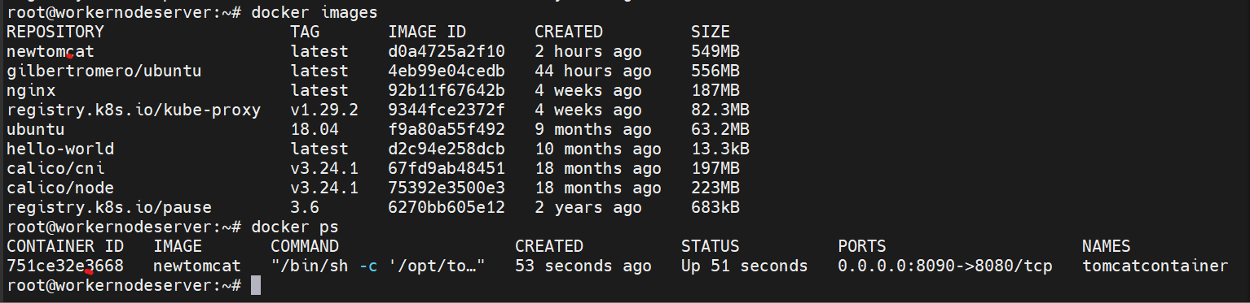

I installed an ansible plugin to enable run my playbook from jenkins 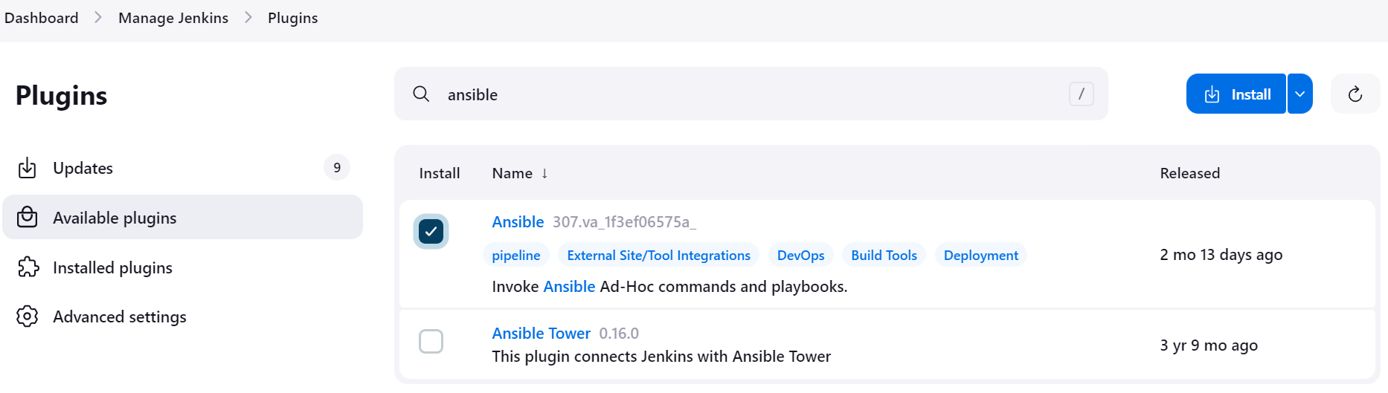 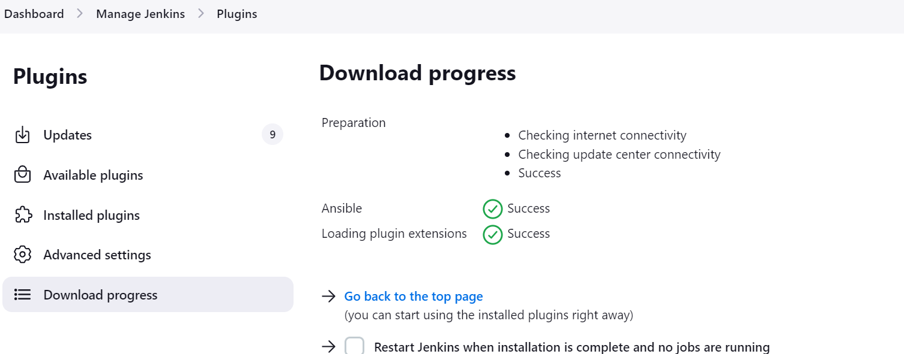

I then configured the ansible path that will be used in the execution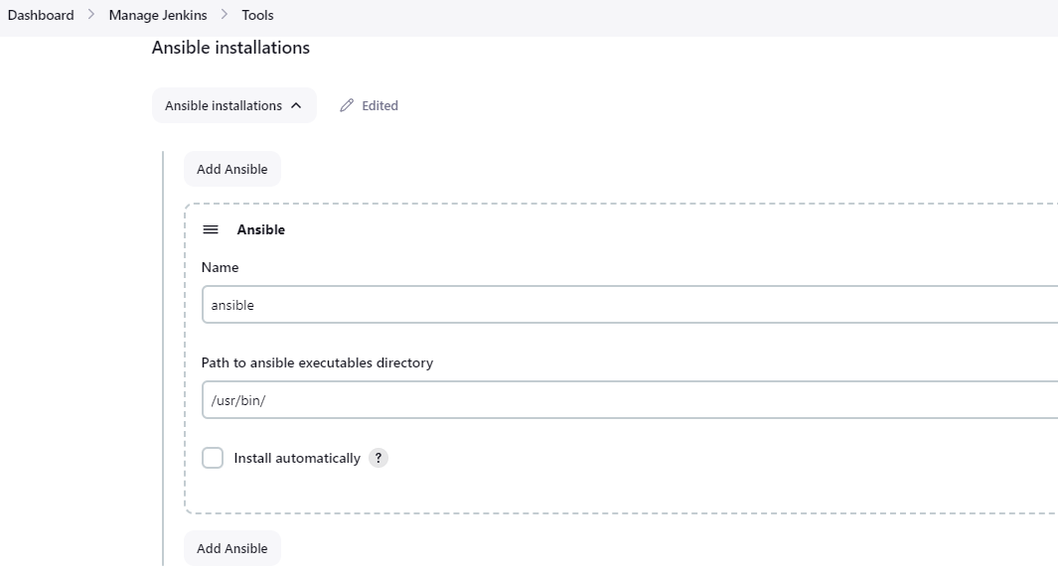

I then created a new freestyle job called package_docker 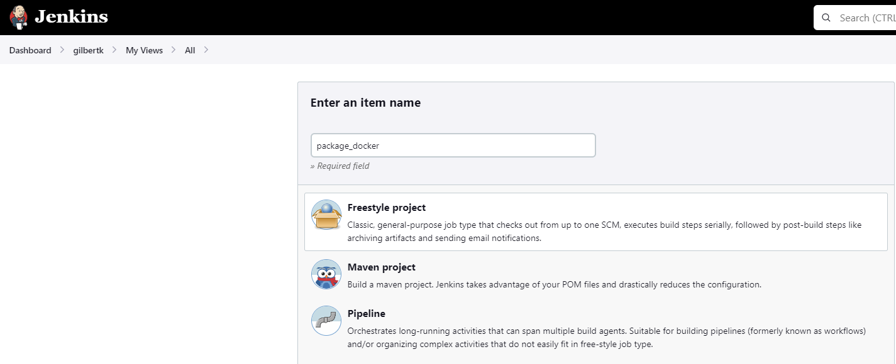 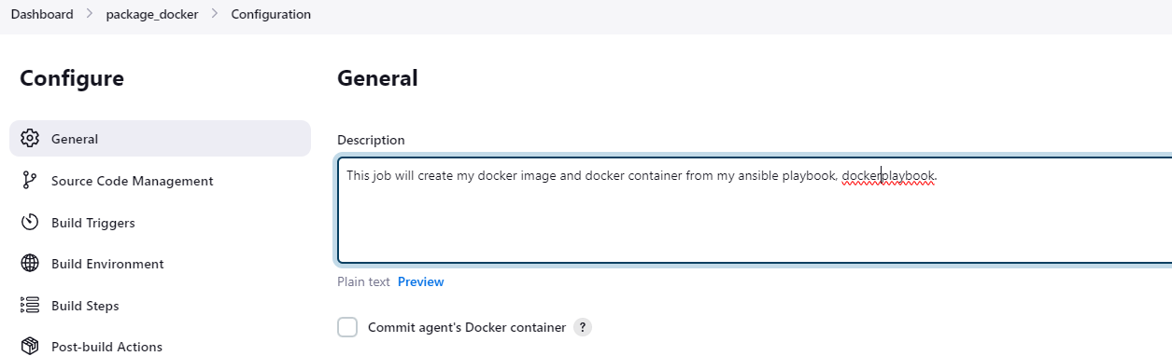

I then ran my package_docker job which failed because I had not configured the ssh credentials 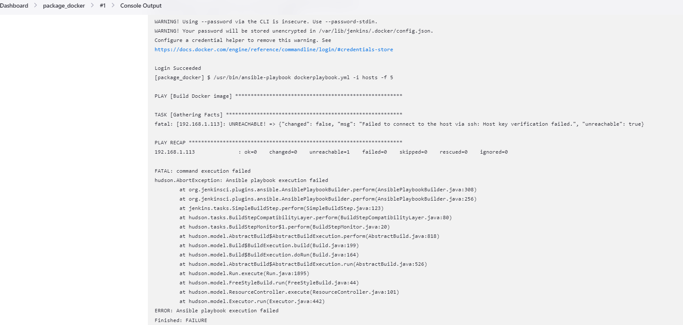

I then configured the ssh credentials which is the private key 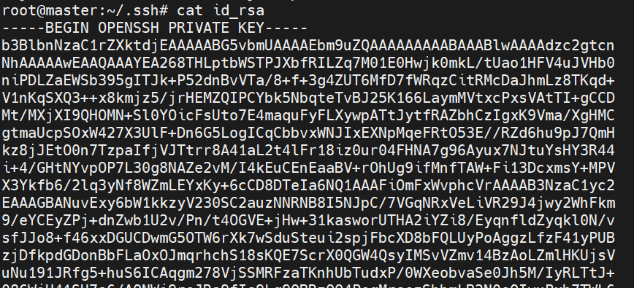

I configured my job adding github 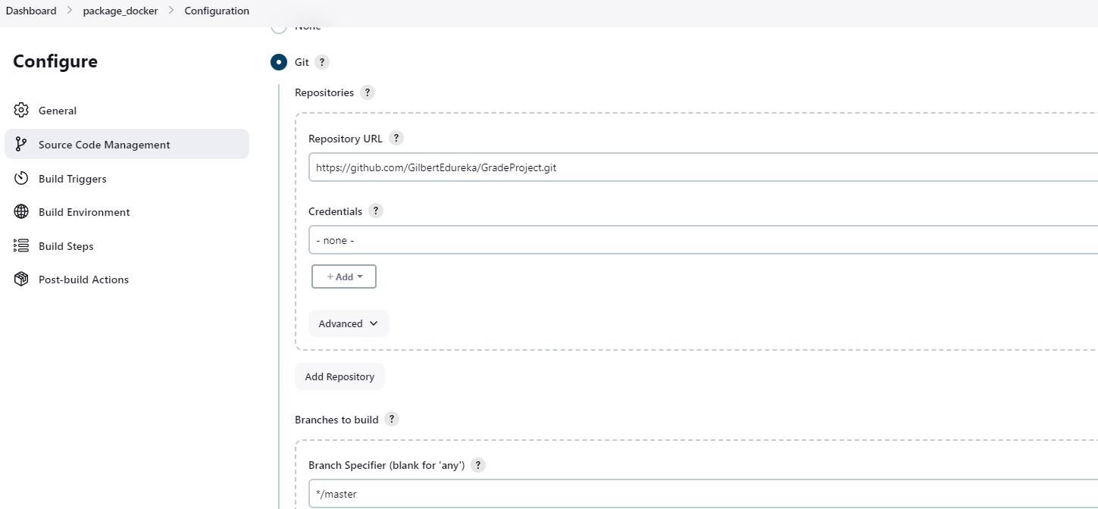 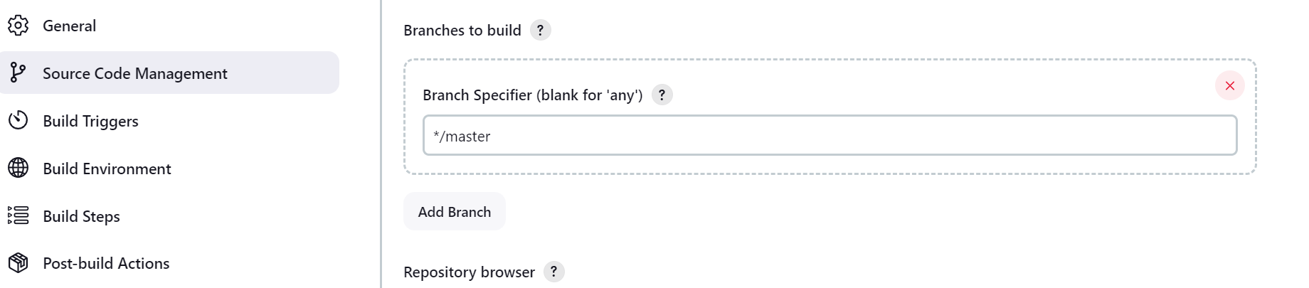

I configured myj Job to run after my test job completes 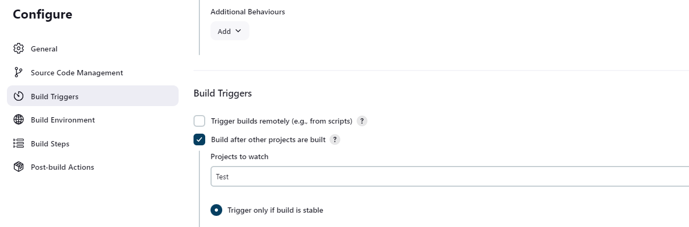

I configured the build step to package the job, log into my docker hub, and create image using my docker file from github. 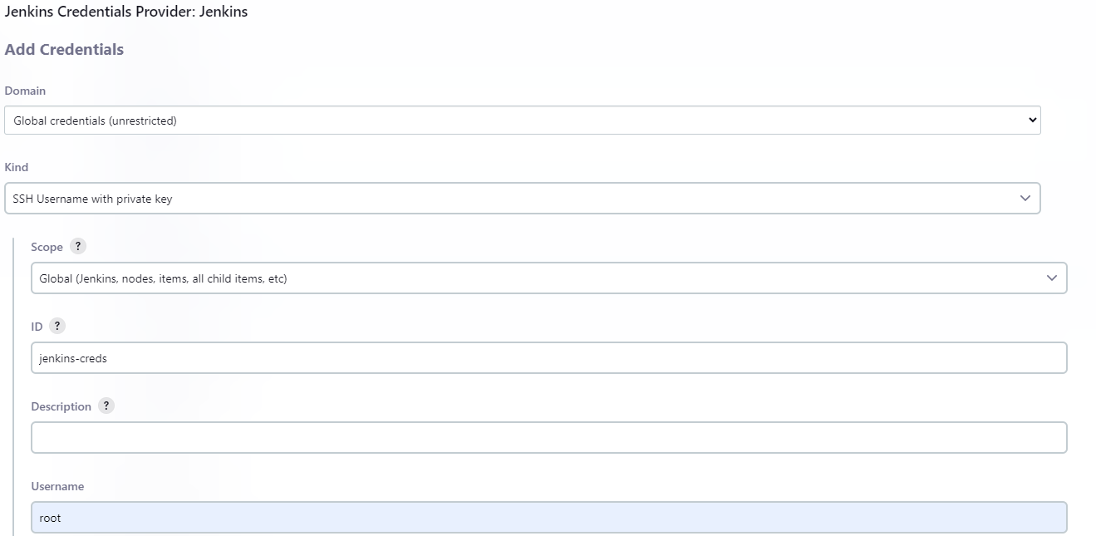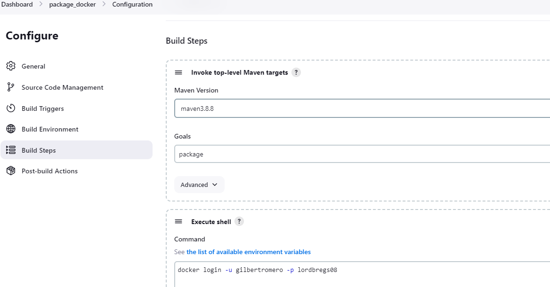 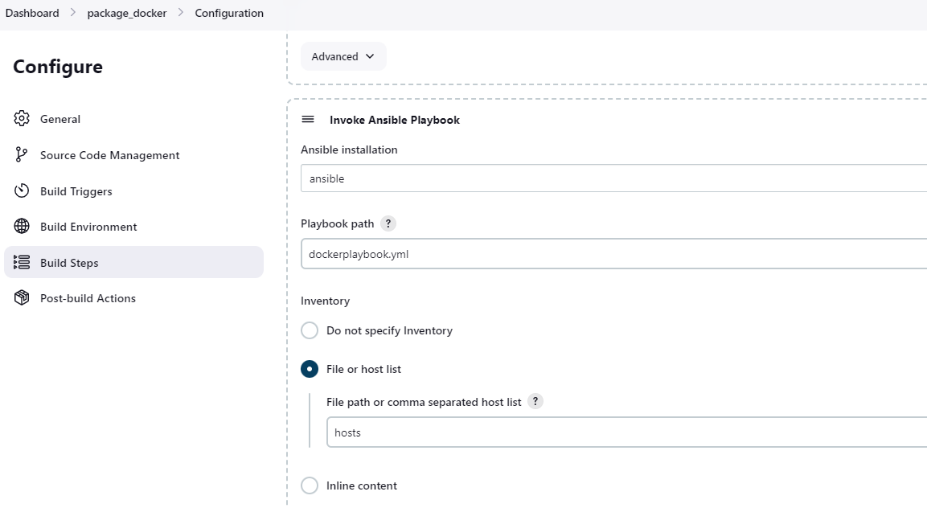 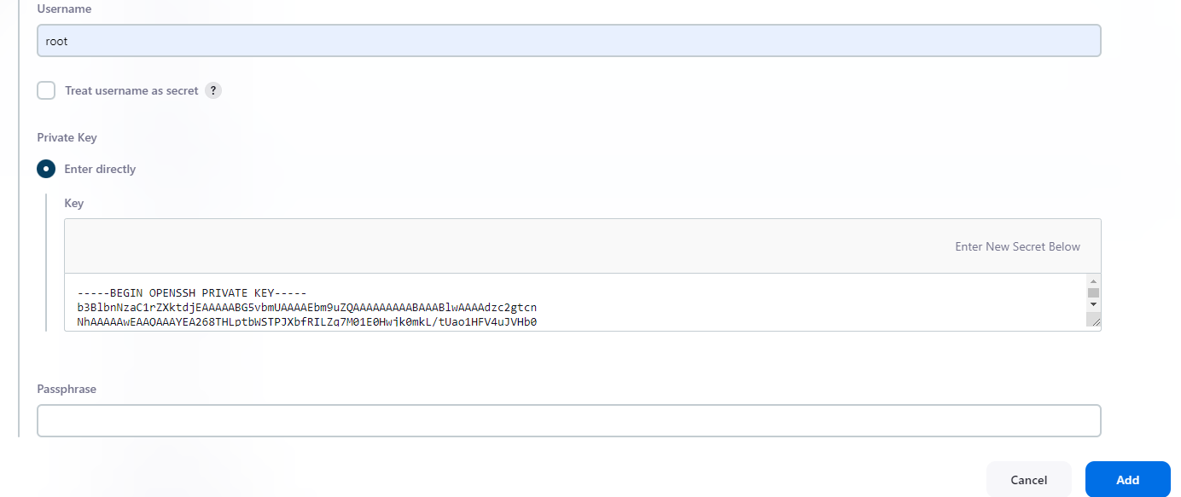 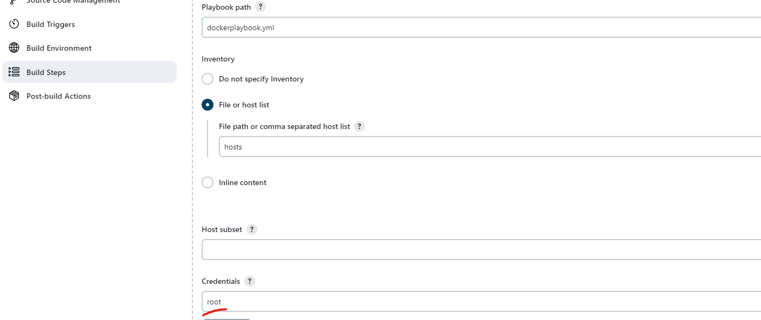

My job then runs successfully 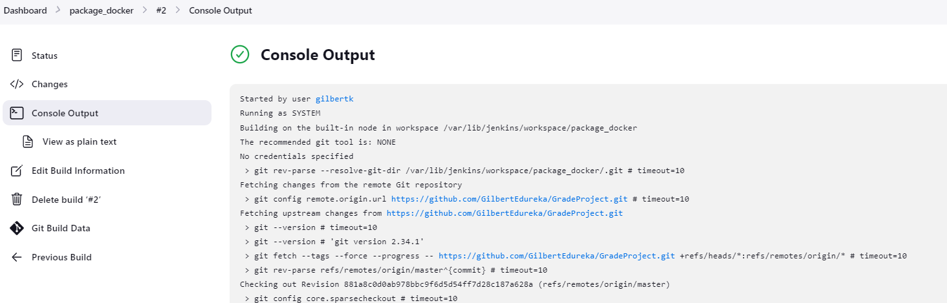 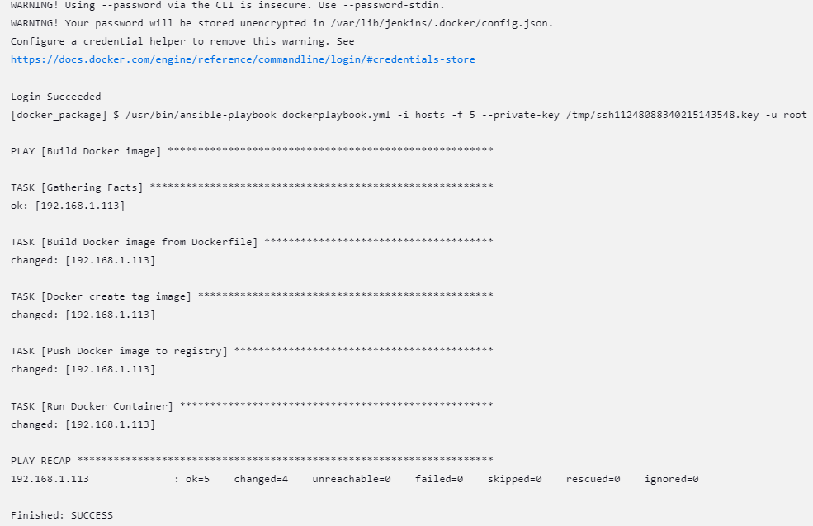

I can see our image and container that has been created but my app cannot be accessed because my war file is not in the container

 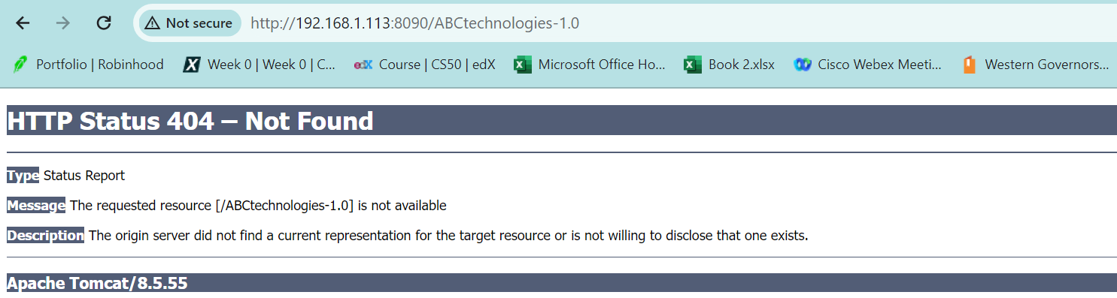

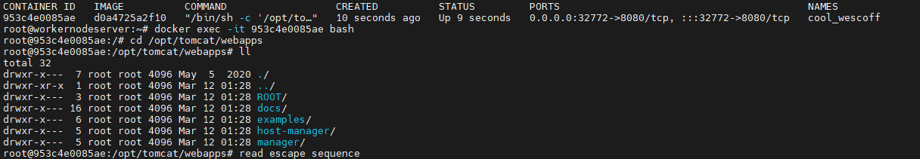

To solve this issue, I added a task in my playbook to copy my target folder containing my war file to my host directory /root/GradeProject and my job runs successfully creating my container with my app 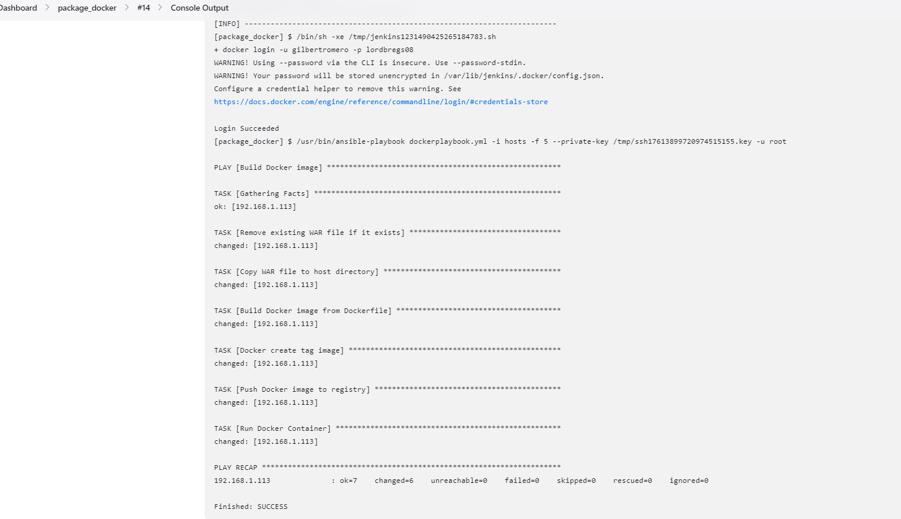

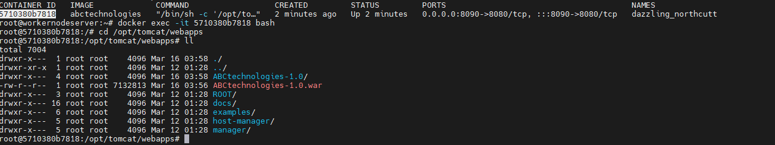 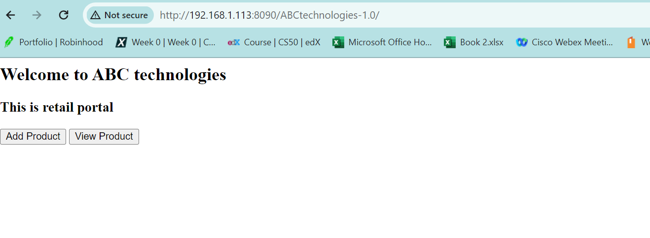

My dockerplaybook.yml will build a Docker image named abctechnologies, tag it with latest, push it to the registry gilbertromero/abctechnologies, and then run a Docker container based on this image. 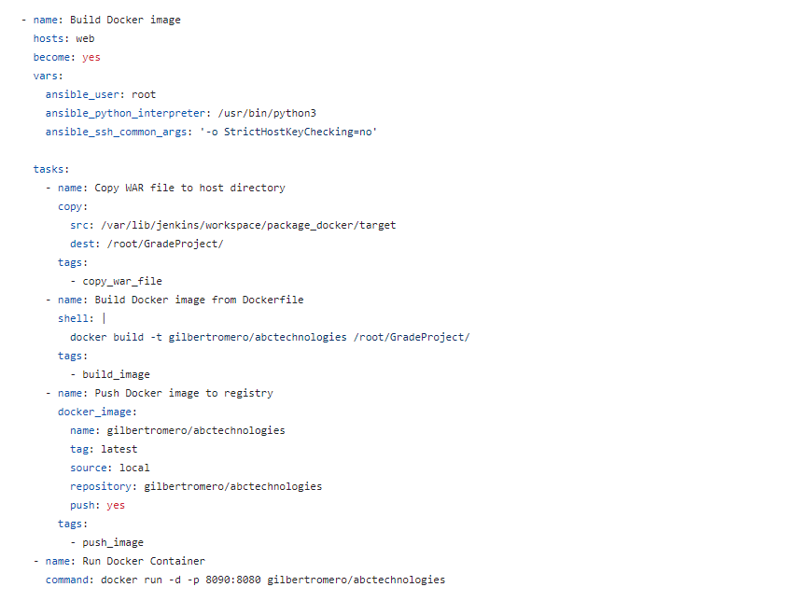

**2.** Now I created my kubernetes manifest files

Pod manifest file

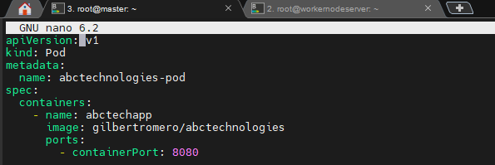 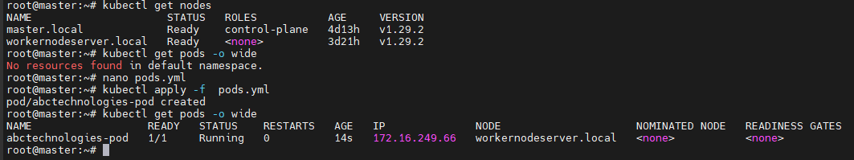

Deployment manifest file

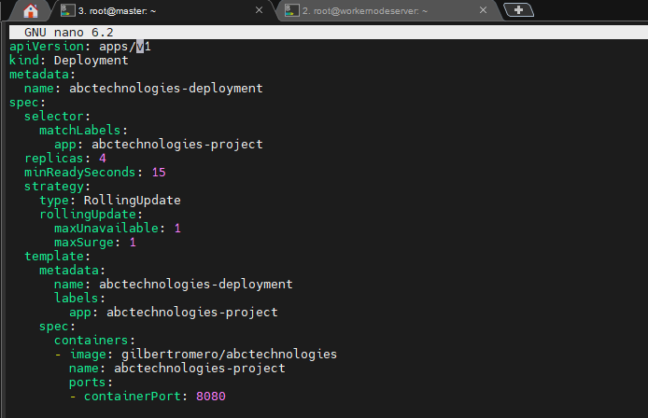 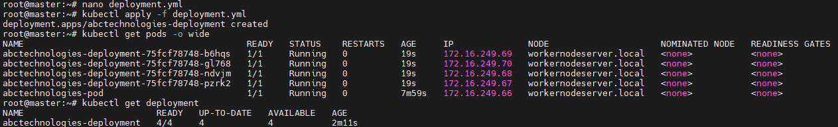

I can see my pod with my war file in it and I can access my application from my IP and nodeport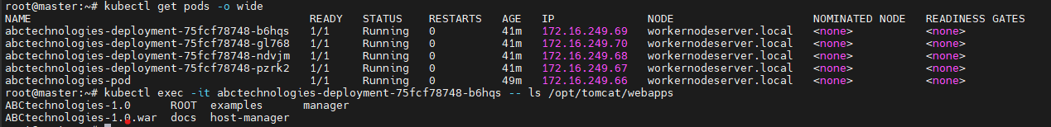 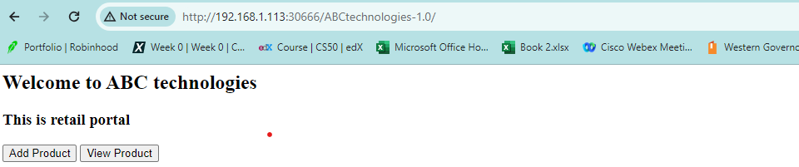

Service manifest file

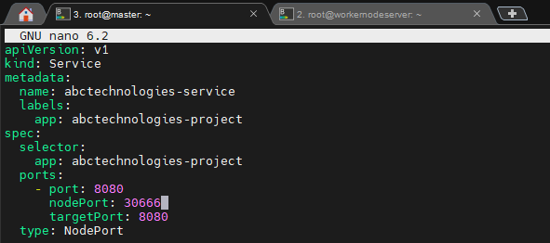 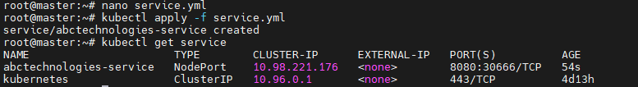

My service  abctechnologies-service has the selector app: abctechnologies-project, which matches the labels of my pods. Therefore, any traffic coming to the service will be automatically directed to my pods.

**3**. To integrate kubenetes with ansible, I created my ansible playbook to execute my create pod, and execute manifest files and create my deployment, services and pods.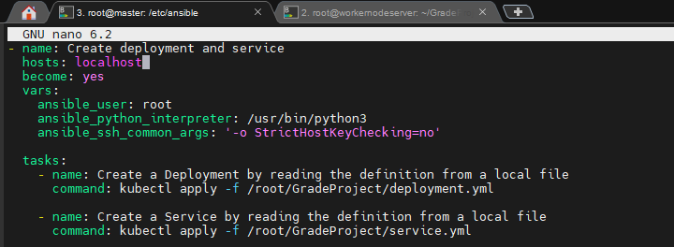

Running my playbook on my local creates my deployment, pods and service 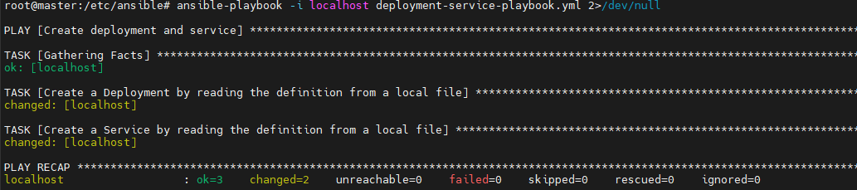 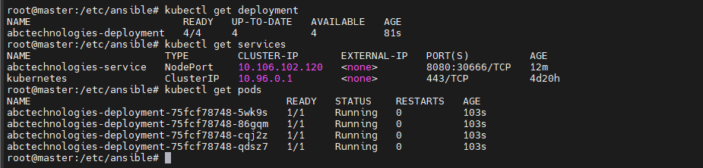

I pushed my playbook, deployment-service-playbook.yml and manifest files to github.

I then updated my host file to have my localhost server since I will be running my Kubernetes job on my master itself.

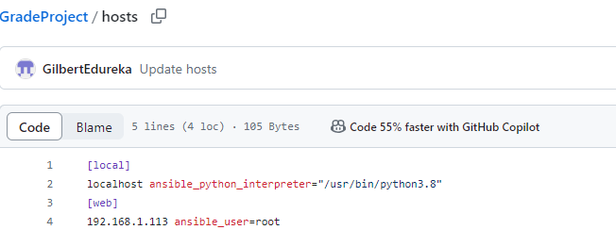

I then renamed my job from package_docker to package_docker_kubernetes.

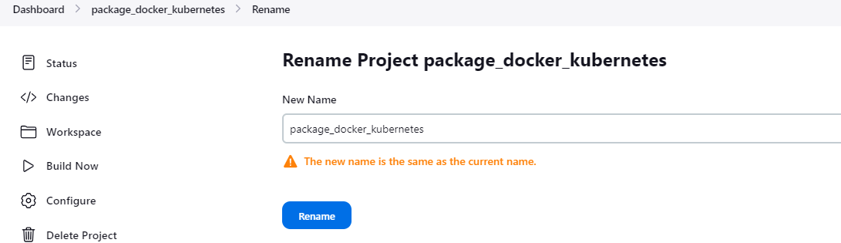 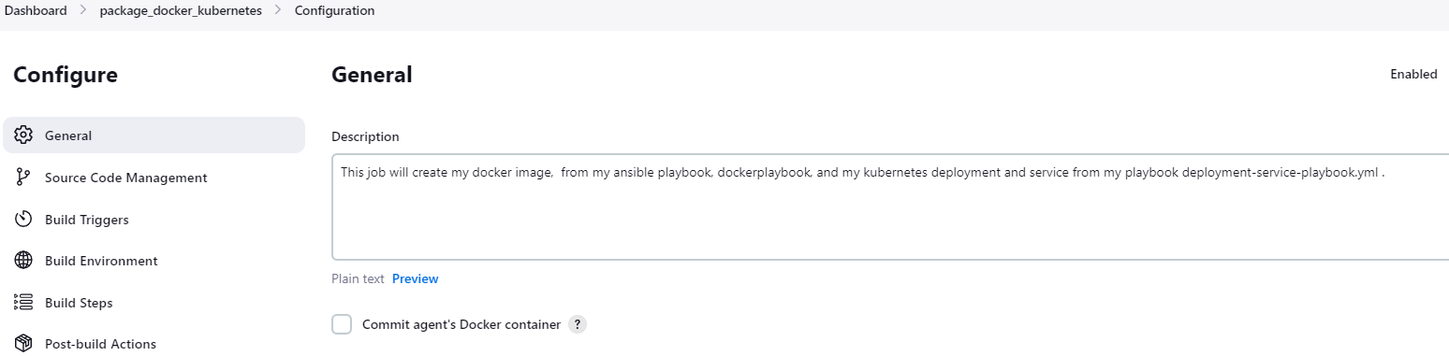

I added another step to my "package_docker_kubernetes" job to run my Ansible playbook, "deployment-service-playbook.yml," and created my deployment after my image is created from my previous step. This job fails because the Jenkins user could not access my localhost.

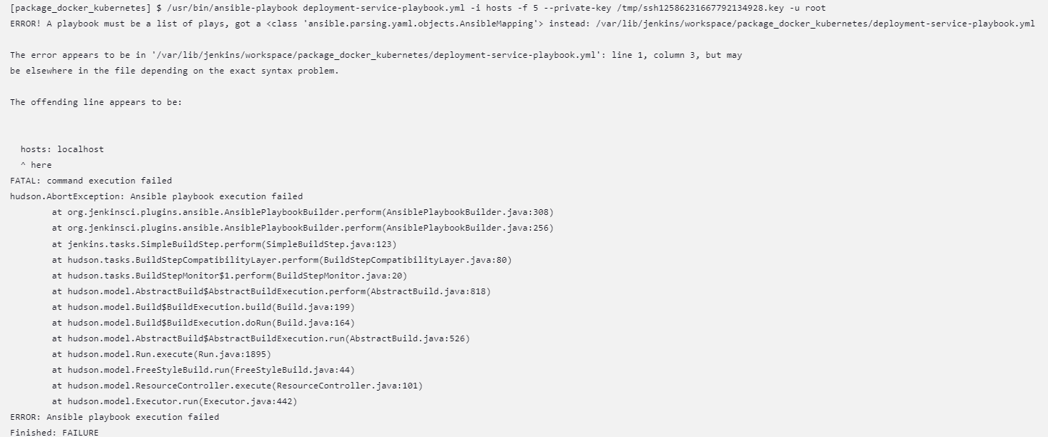

I then created an ssh connection between my worker node, master and Jenkins as I had done when running my previous step to create my image 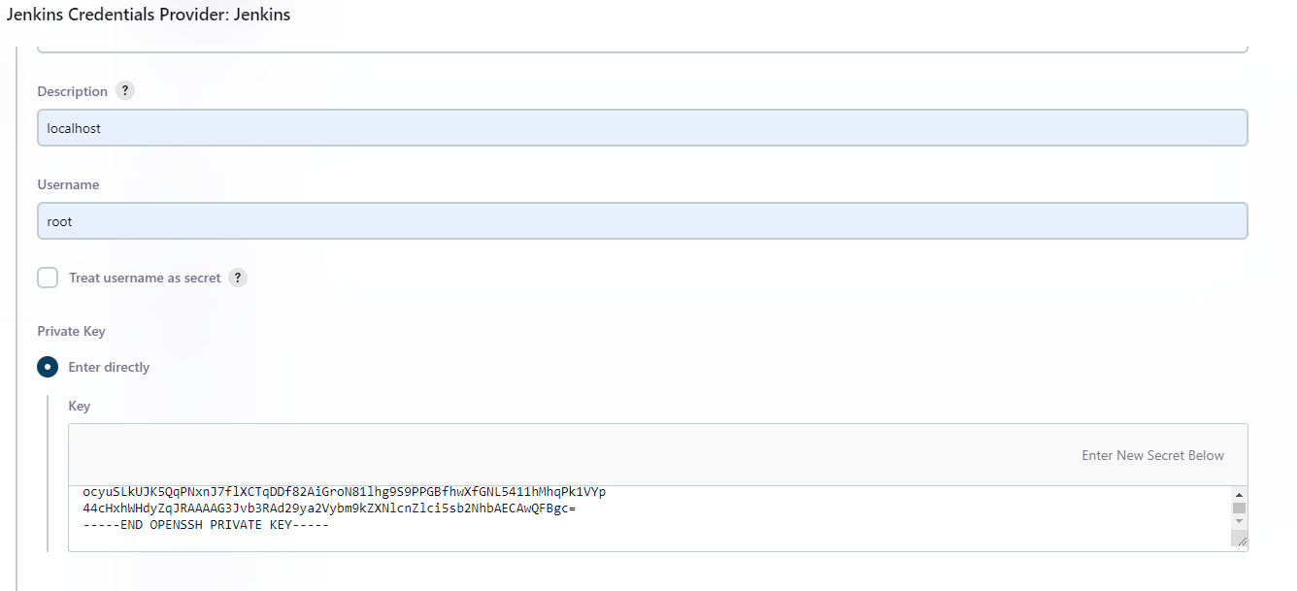

I then configured my build step with the credentials just I had just created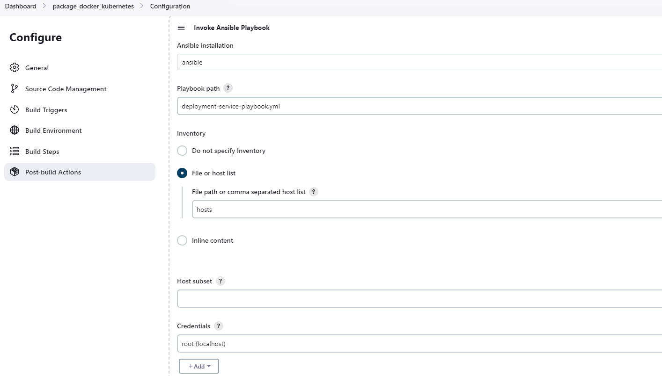

I set up PollSCM and triggered my job from compile by updating my README file.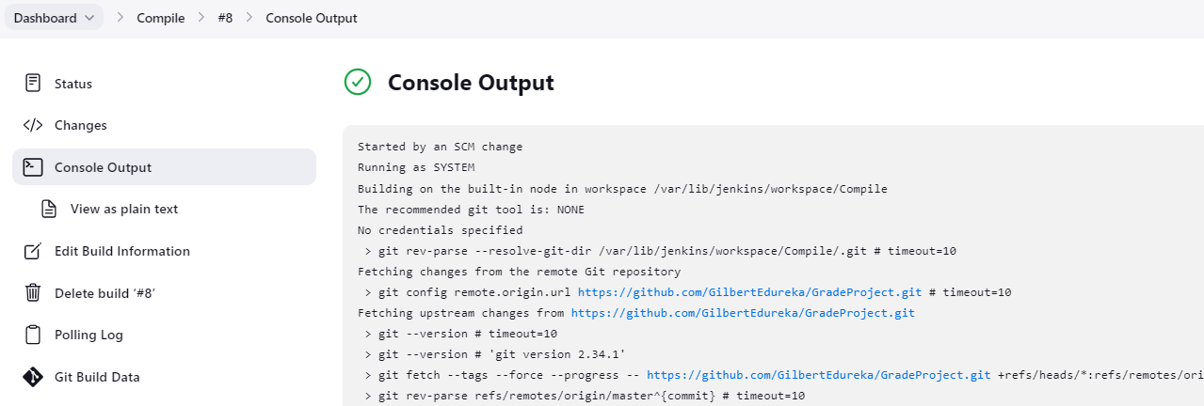 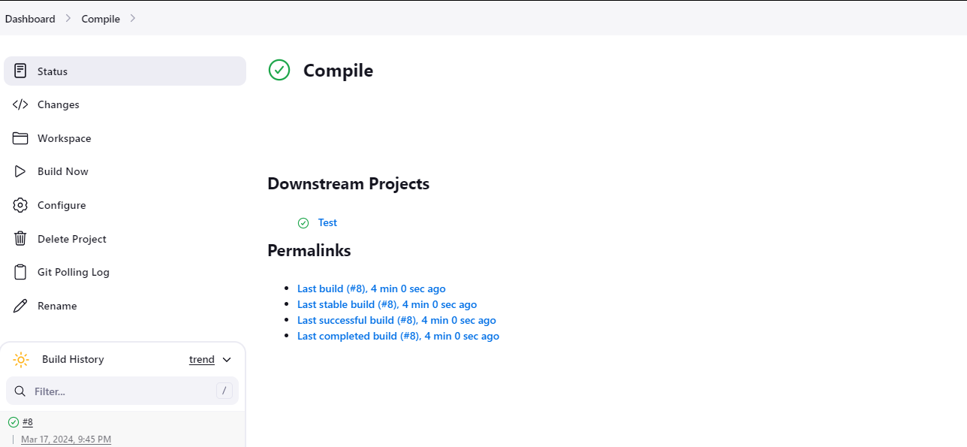 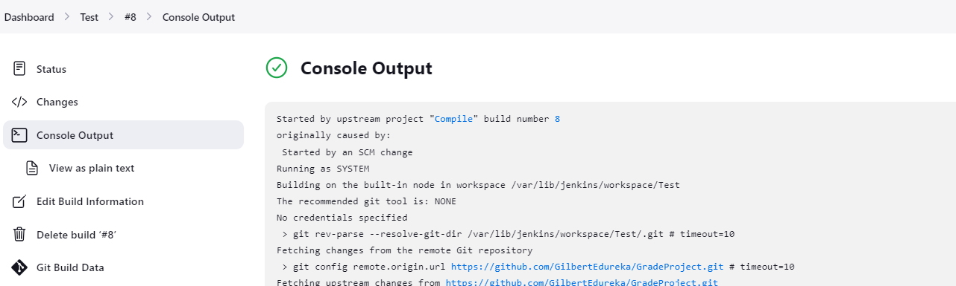 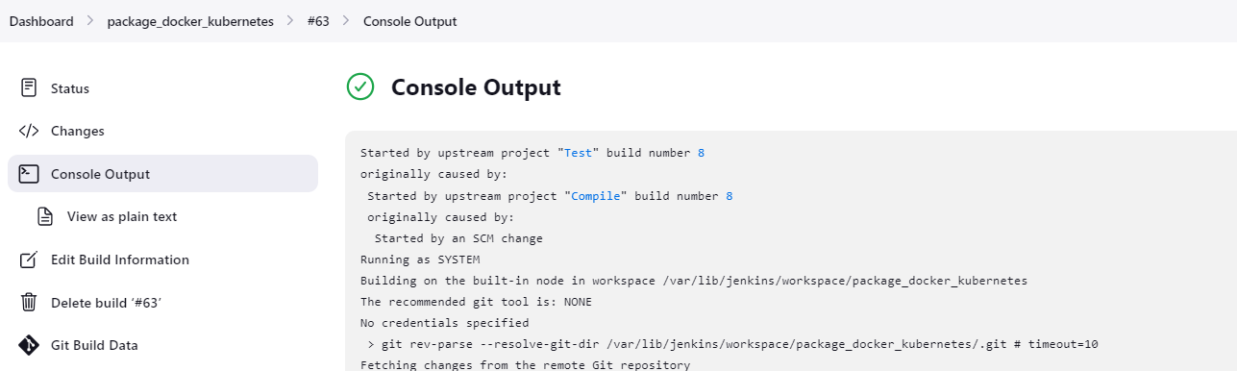

My job runs successfully

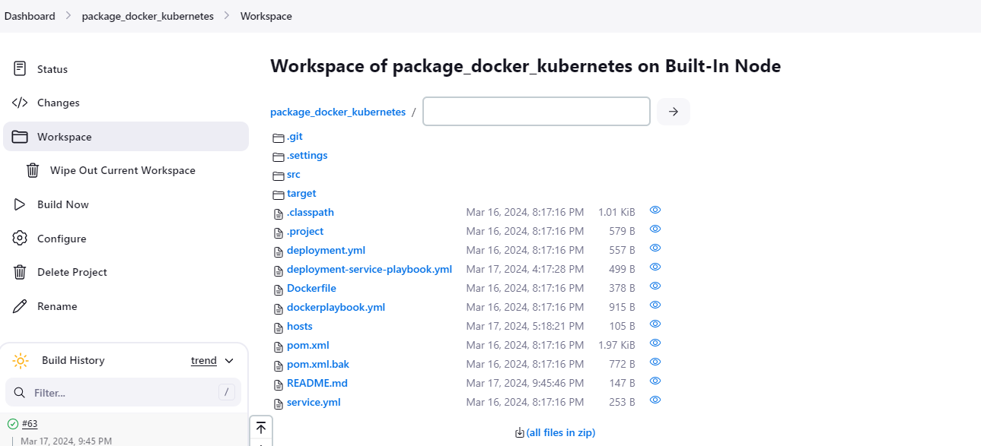 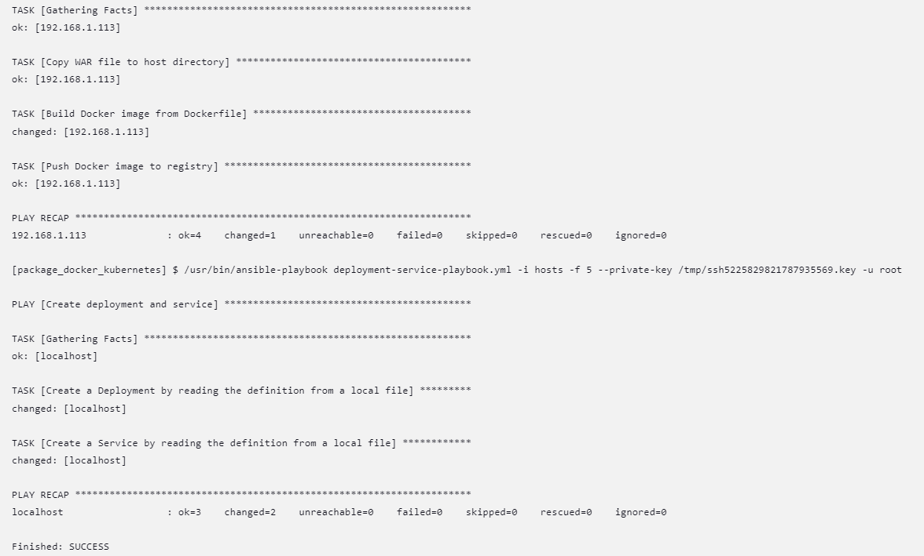

The packaging completes and my war file is created.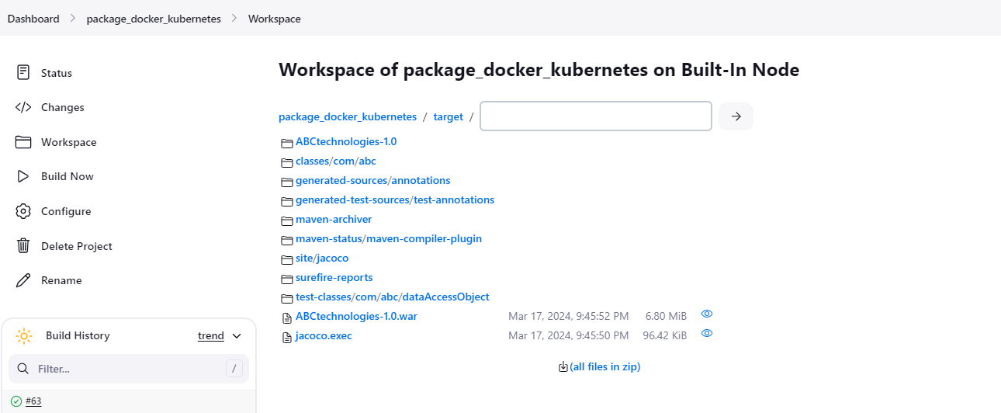

It also created and deployed my docker image to docker hub 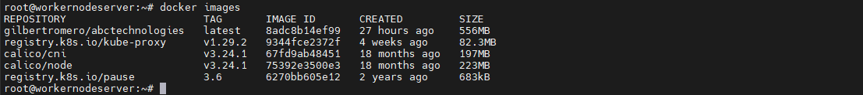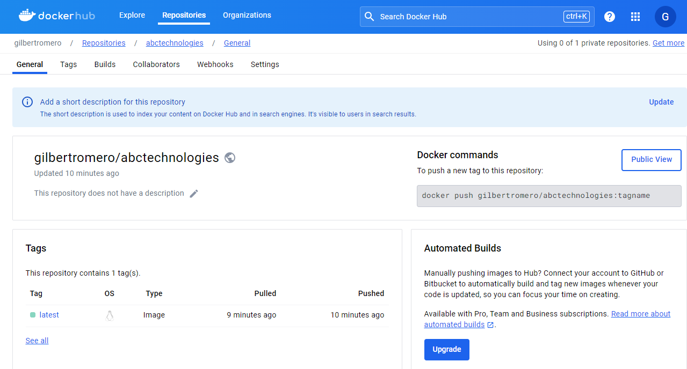

This image is then utilized by my next playbook, deployment-service-playbook.yml to create my deployment, pods and service 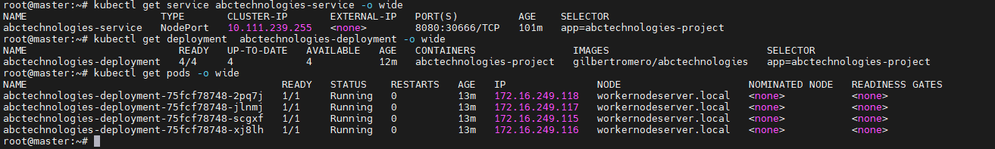

I can also see my war file in the container and access my application on the web 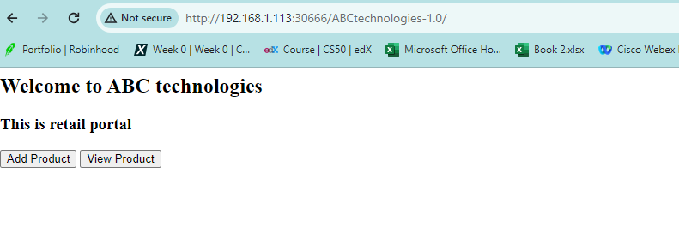

**Task 5: Using Prometheus, monitor the resources like CPU utilization: Total Usage, Usage per core, usage breakdown, memory, and network on the instance by providing the endpoints on the local host. Install the node exporter and add the URL to the target in Prometheus. Using this data, log in to Grafana and create a dashboard to show the metrics.**

To accomplish Task 5, I monitored resource utilization using Prometheus. Firstly, I installed Prometheus on a dedicated server created for monitoring, named 'monitoring server.' Then, I installed the node exporter on the target servers and added their URLs to the monitoring server's prometheus.yml file. Following this, I configured Grafana to visualize the metrics. Upon logging in to Grafana, I created a dashboard to display CPU utilization, encompassing total usage, per-core usage, breakdowns, as well as memory and network metrics.

I created a new server and renamed it “monitoring”. I installed prometheus on my server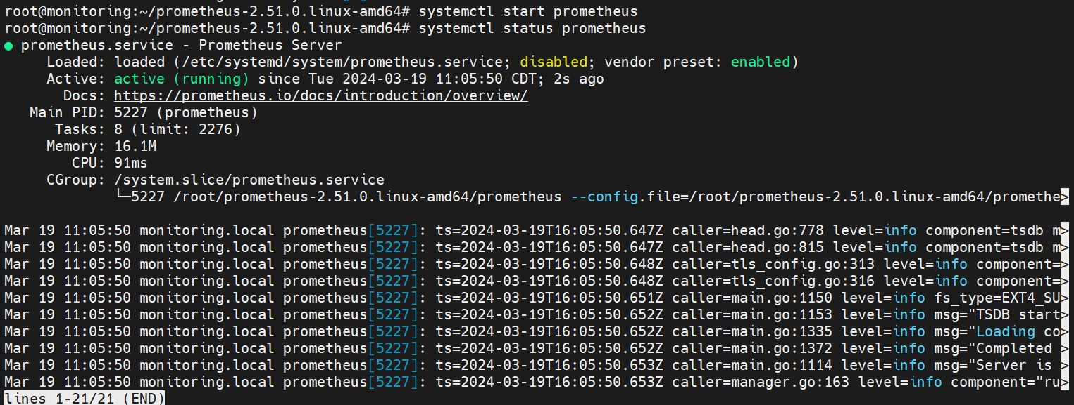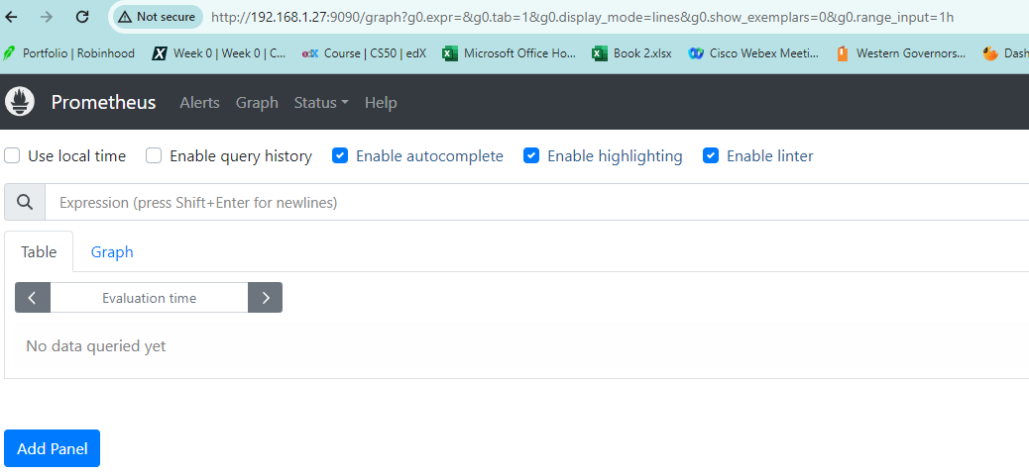

I then instaled Node Exporter to my targets which are my master and workernode servers.

nano /etc/systemd/system/node_exporter.service

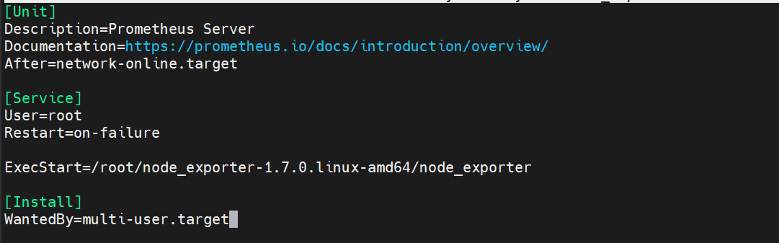

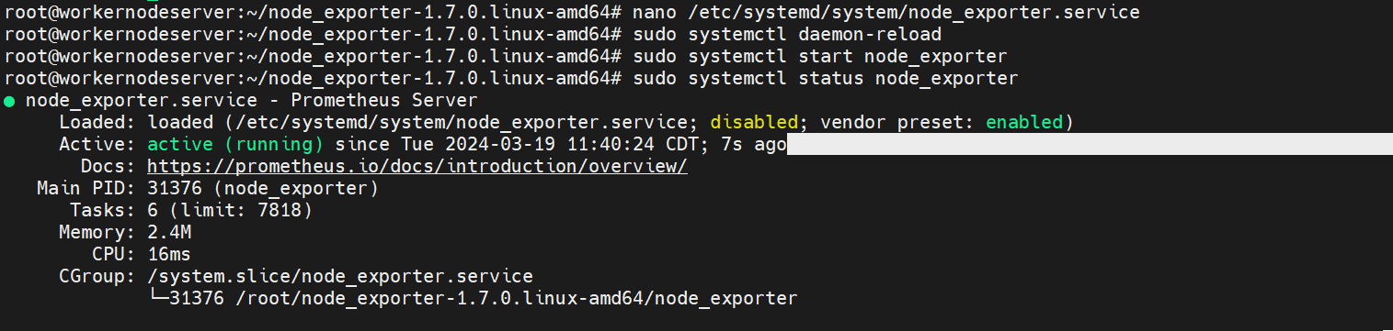

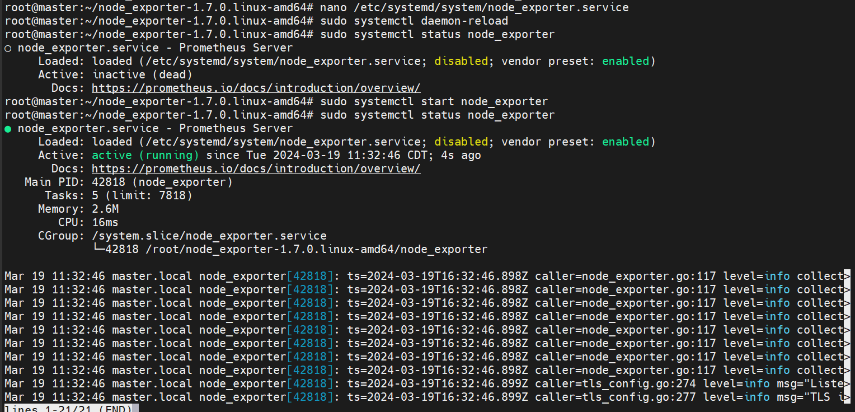

Since node experter is a service that runs on port 9100, I then attached my targets to my monitoring server by adding the ip address of my targets with valid node_exporter port to the prometheus server.

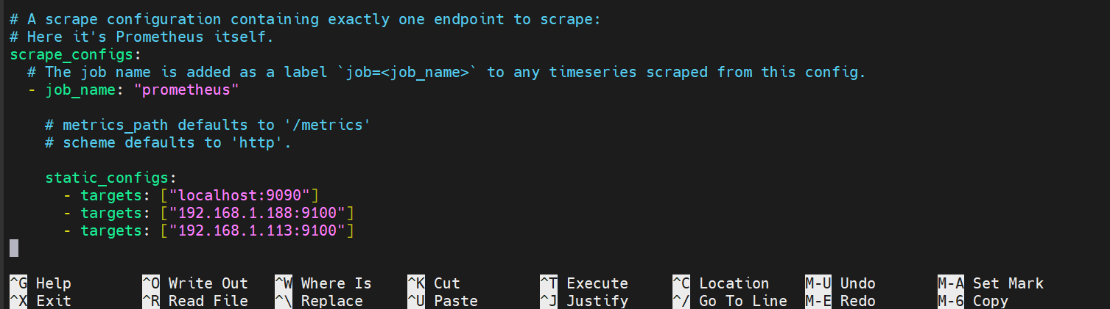

Restart the service, systemctl restart prometheus. Now I can see my target servers on the ui 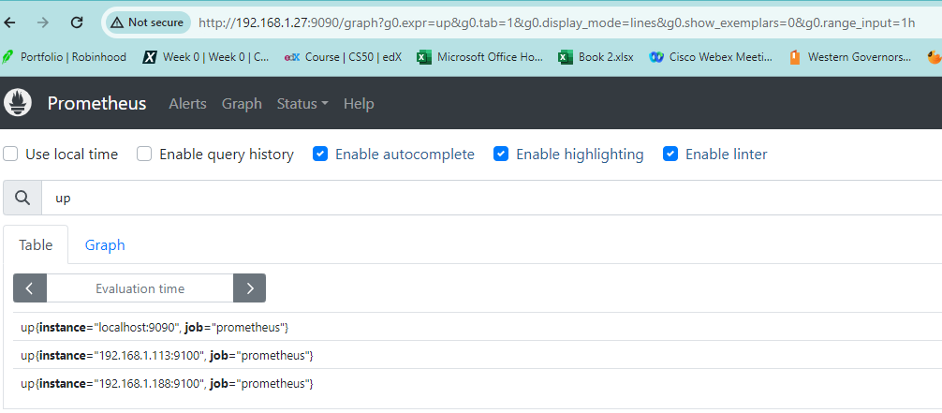

Example graph to monitor my cpu use from the last 10 minutes 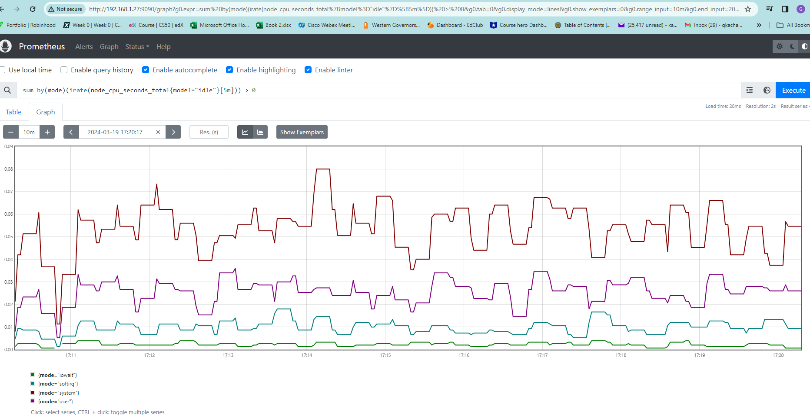

I then installed grafana on my monitoring server in the same directory of promrtheus 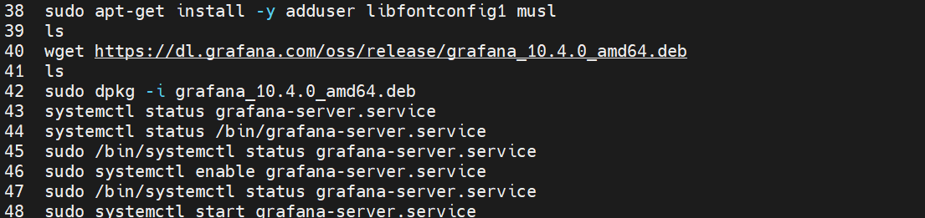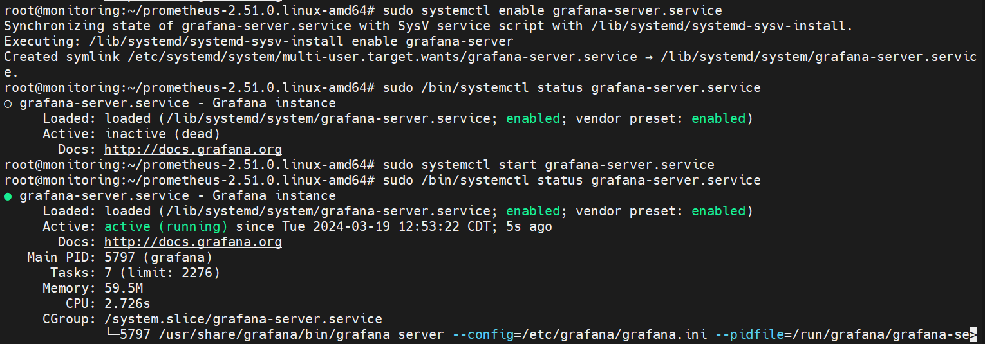

Since grafana is a service that runs on port 3000, I was able to login into grafana ui using my ip address and the port number. I used the initial user name “admin” and password “admin” which I later reset.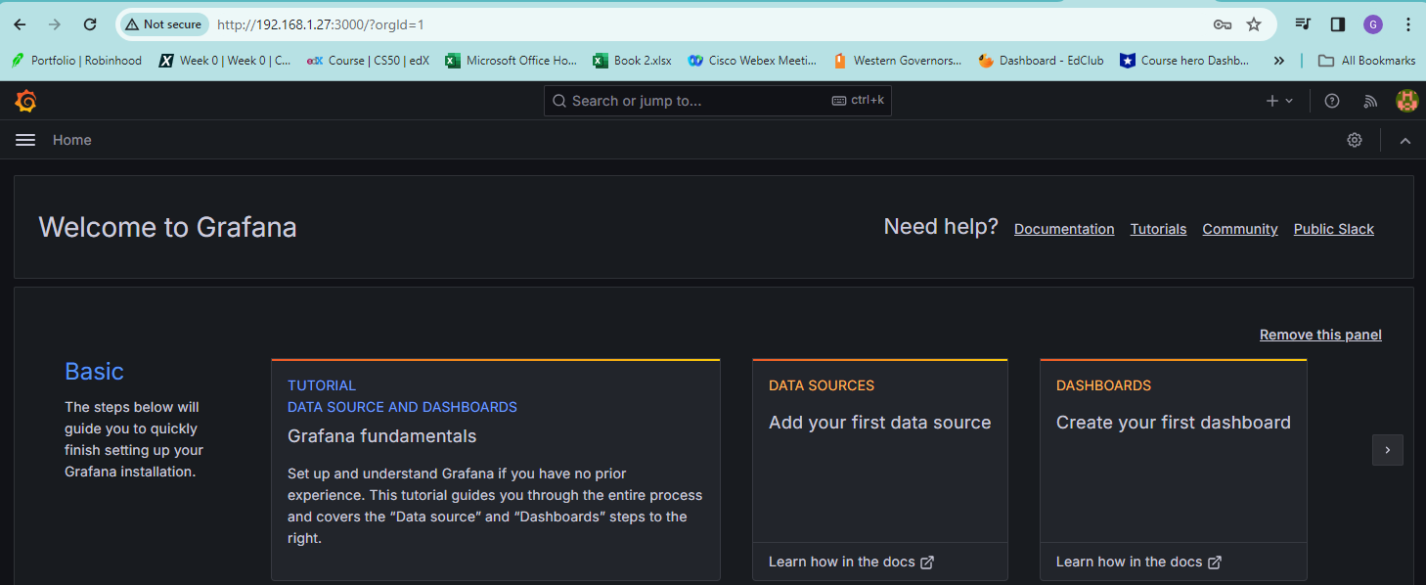

I then added Prometheus as a data source to grafana on my grafana dashboard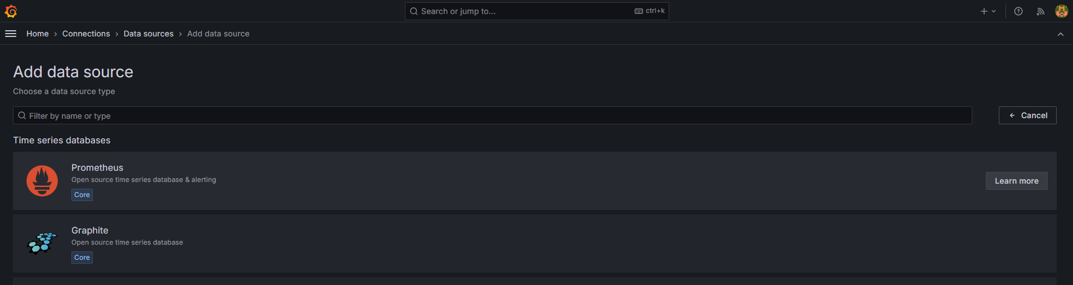

I configured my prometheus url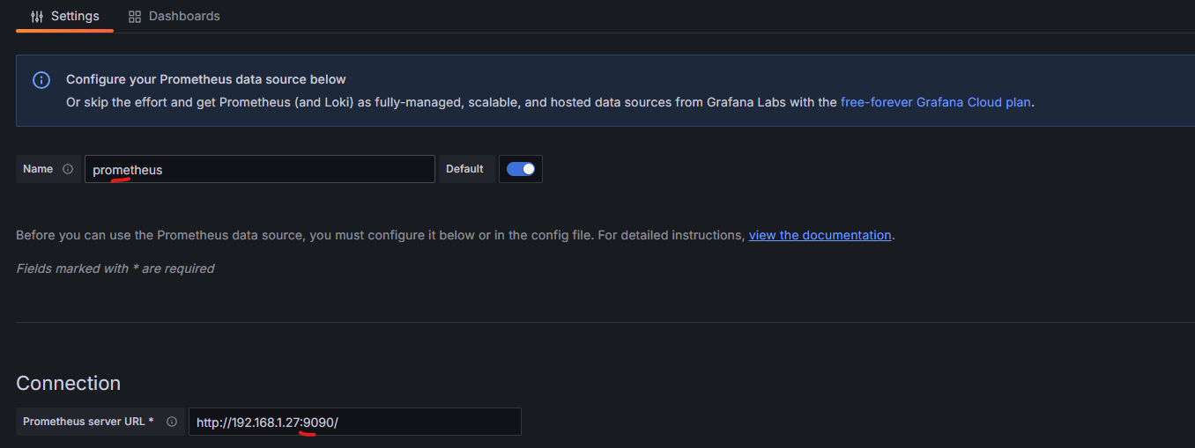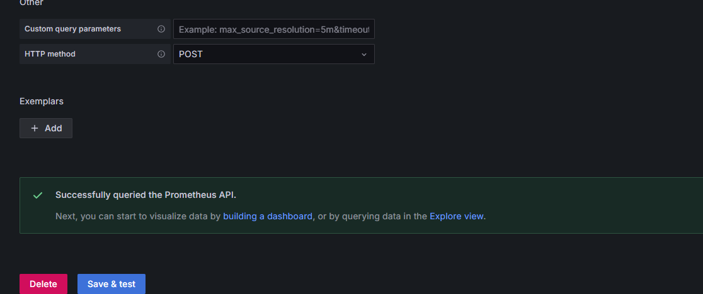

Now I created my dashboard to monitor and capture the CPU, memory and network of my target nodes from the last 30 minutes. I selected prometheus as my datasource, and entered my query in the metrics browser.

Total Usage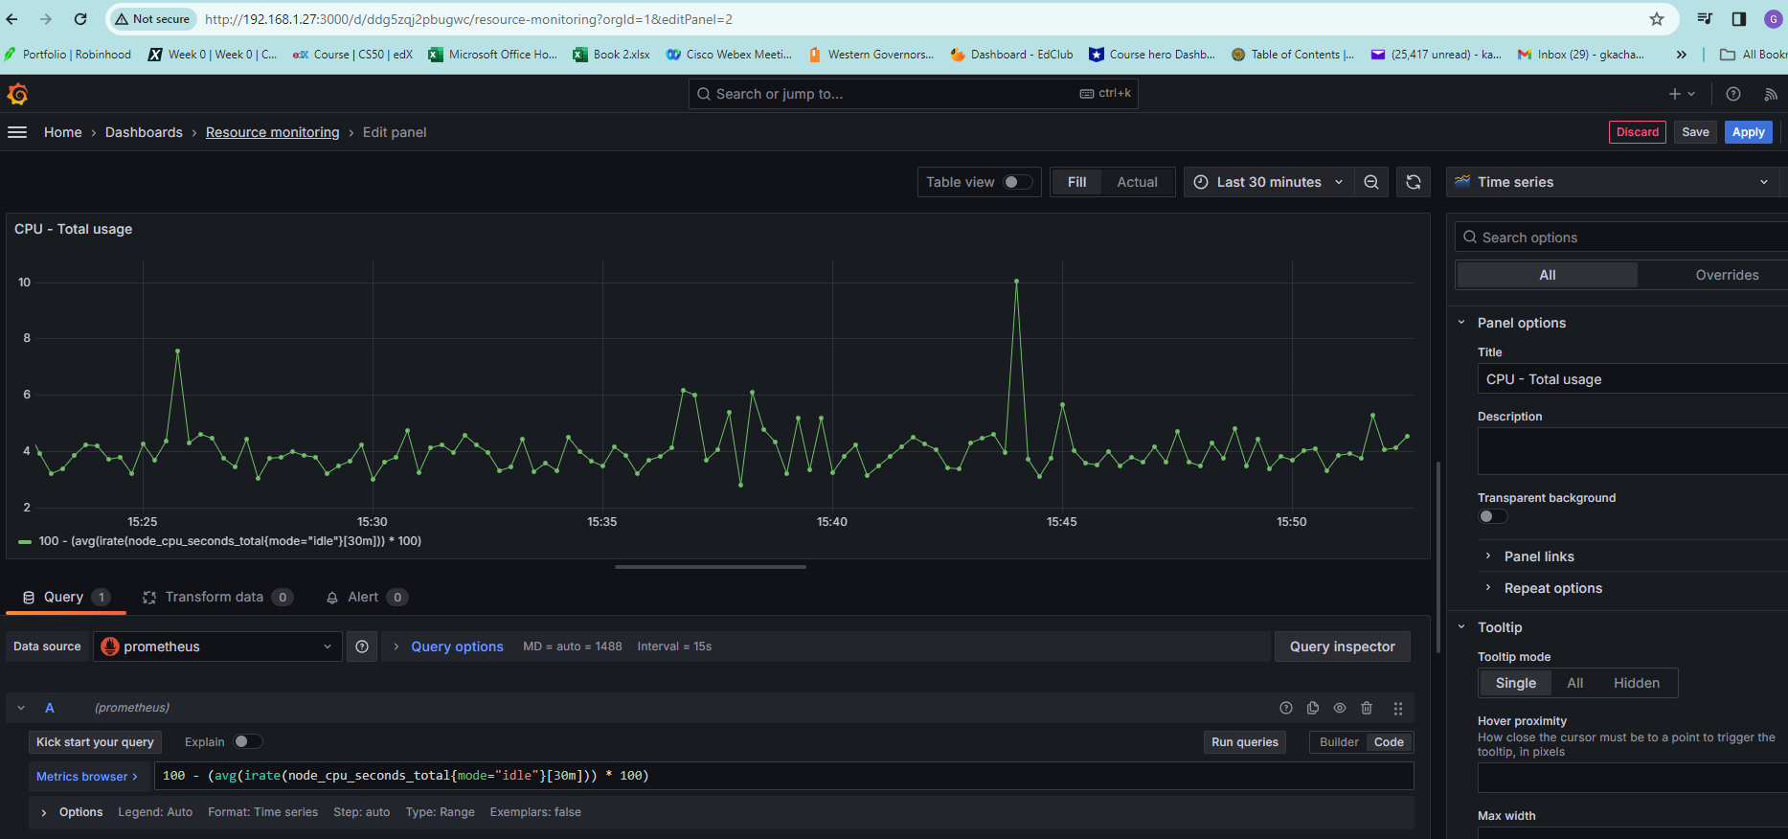

Usage per core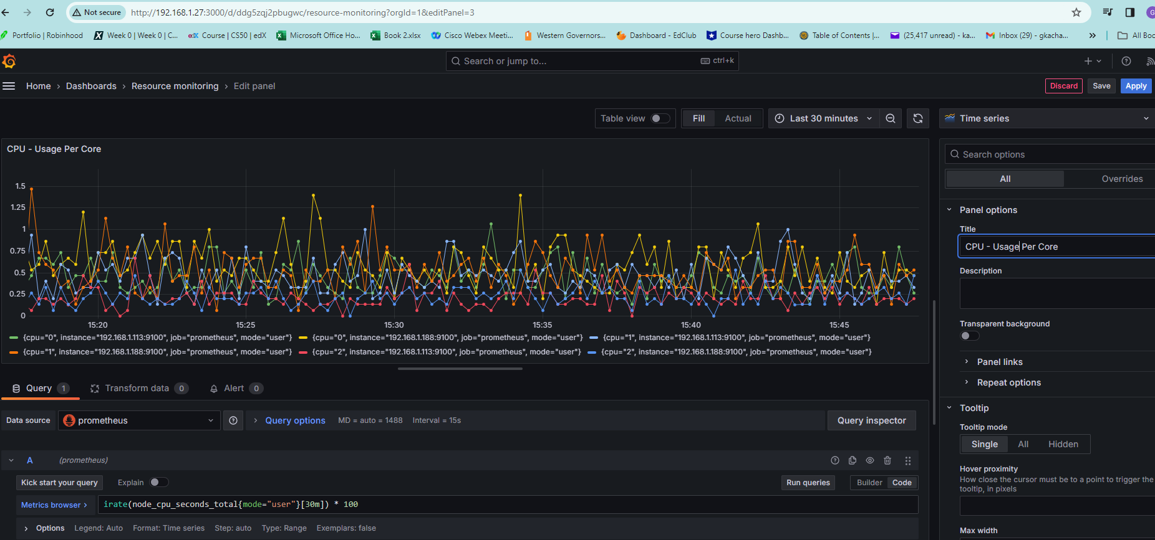

Usage breakdown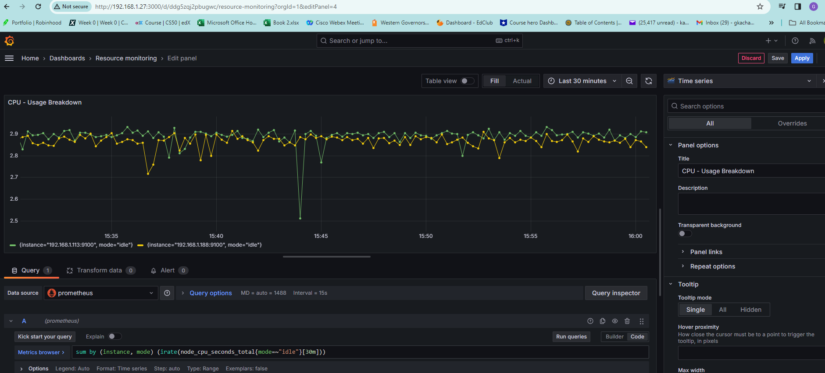

Memory Available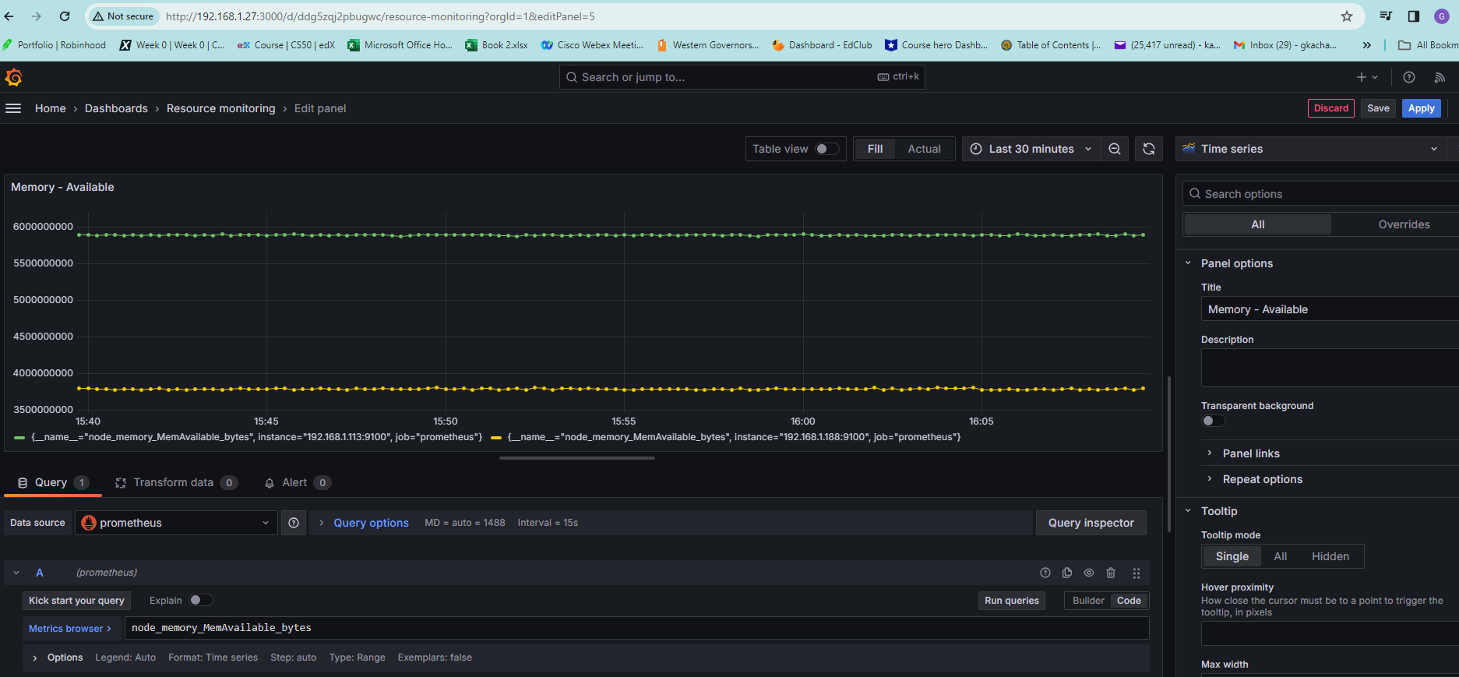

Network Received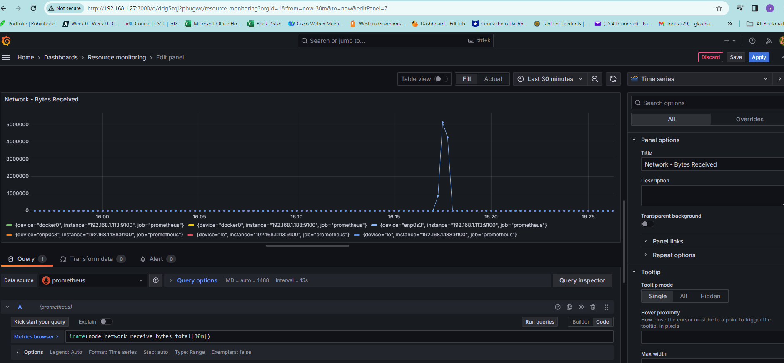

Network - Transmitted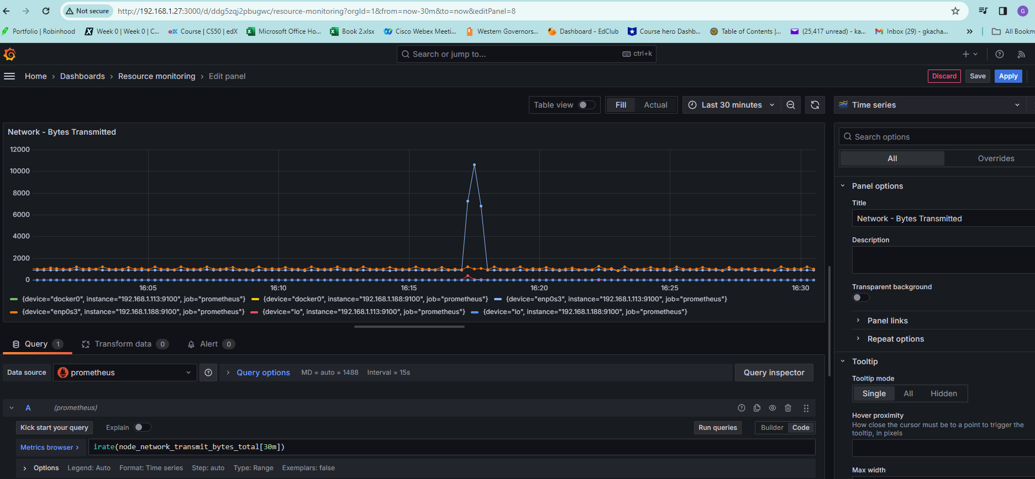

My monitoring dashboard 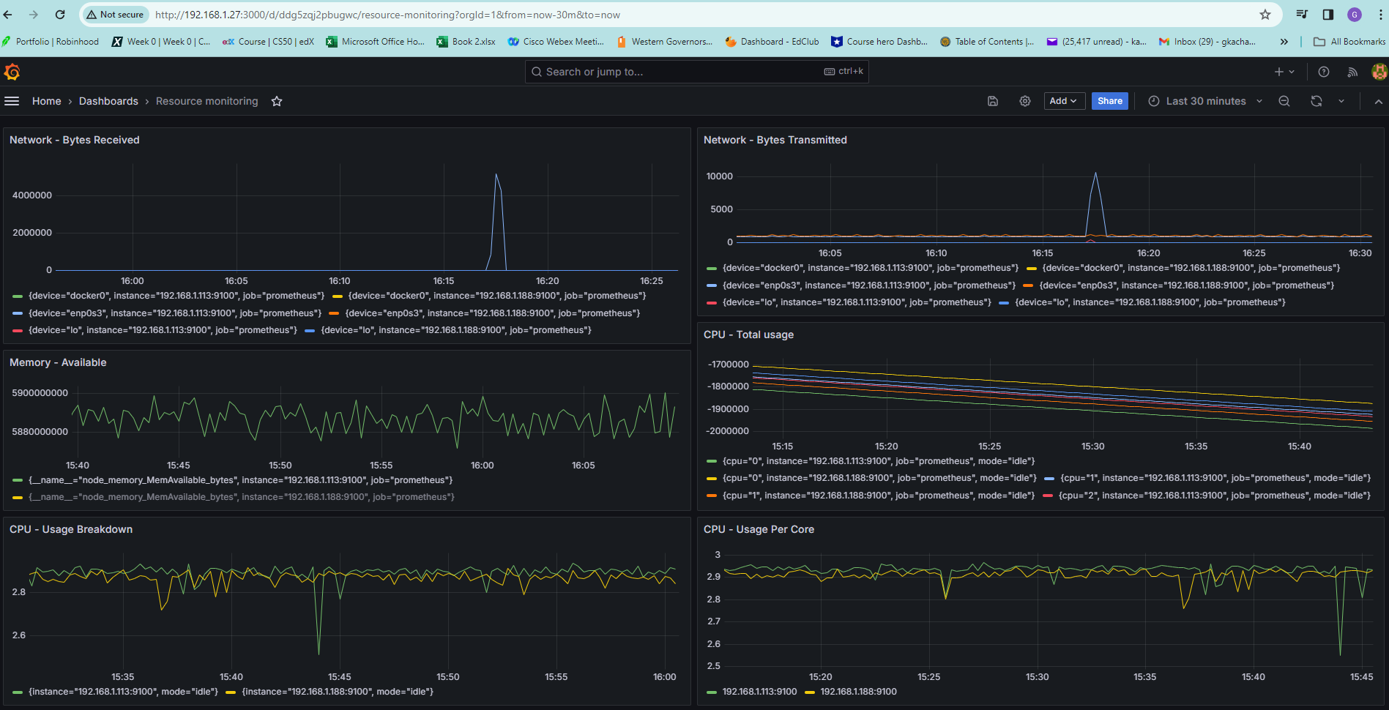

Before triggering my pipeline 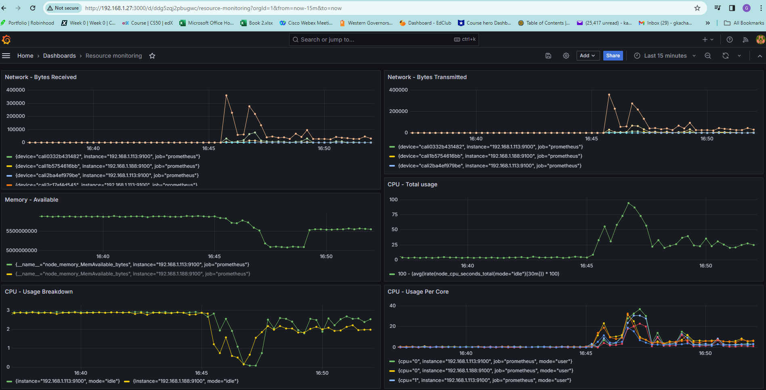

After my pipeline completes 